**Developing Paper Shadow Puppets as Media for History Learning at SHS’s**

**Zulita Andan Sari1, Drs. Muhamad Nur Rokhman, M.Pd2**

1,2 History Education Study Program, Faculty of Social Sciences, Yogyakarta State University

1[zulitasari174@gmail.com](mailto:zulitasari174@gmail.com), 2[m_nurrokhman@uny.ac.id](mailto:m_nurrokhman@uny.ac.id)

**ABSTRACT**

This study is to investigate, (1) the development of paper shadow puppets as media for history learning at SHSs, (2) the appropriateness of paper shadow puppets as media for history learning at SHSs according to media and materials experts, history teachers, and students. The method of this research was R&D method. The results of the study were as follows, (1) the stages of the development included the identification of potentials and problems, data collection, product design, product validation, product revisions, product tryout, product revision, and application tryout, (2) the validation by the media expert attained a final mean score of 98% with the very appropriate category and that by the materials expert attained 98% with the very appropriate category. The validation by the history teachers attained a final mean score of 94% with the very appropriate category and that by the students attained 93% with the very appropriate category.

**Keywords**: History Learning, Learning Media, Paper Shadow Puppets

1. **INTRODUCTION**

Education is an effort made consciously by humans to develop the potential they have, so that it can improve a person’s degree of life, facilitate someone to get a job, and also improve the quality of oneself through teaching and training.(Sugihartono, et al, 2015: 4) The delivery of education can occur everywhere, anytime and by anyone, so it is divided into informal, formal and non-formal education.(Cepi Safrudin Abdul Jabar, et al, 2016: 15) The difference between the three types of education implementation is in the form, management, organization that accommodates each activity.

The implementation of the 2013 curriculum is currently according to H.E. Mulyasa (2014: 65) will produce Indonesia’s young generation who are productive, creative, innovative, affective, through the formation of integrated attitudes, skills and knowledge. This has caused the assessment of student learning to be carried out on spiritual, social, knowledge, and also practical aspects. The 2013 curriculum emphasizes the activeness and character building of students in every teaching and learning process, so the teacher’s role is only as a facilitator. According to Daradjat (in Supriyadi, 2015: 76) teachers are tasked with conveying and distributing knowledge, provide skills training, also instilling attitudes and values to students.

The 2013 curriculum principles that prioritize student activeness can be realized through the use of learning media. However, until now it seems that the use of interactive learning media is still not able to be applied by some teachers, including history subject teachers.

All this time, history subject is subjects that do not attract students’ interest, because they are considered old-fashioned and boring,despite the fact that learning history can provide education for students about the past to the future. Students are required to be able to reconstruct the past and then applied to the present situation. In addition, learning history can also provide character education for students and the formation of an attitude of nationalism (Zahro, et al, 2017: 5).

The values contained in history learning are part of the 2013 curriculum implementation, which emphasizes character building. Therefore, history is a compulsory subject for every level of education, from elementary to high school.

The learning media used in history learning are still limited to power points, pictures, textbooks, and videos. The use of three-dimensional learning media, such as temple miniatures or mockups, pop-up books, and other interactive learning media have not been maximized by the teacher. According to Abdul Gafur (2012: 105) media is a tool or a means of delivering messages that are divided into hardware and software. The use of learning media cannot always determine the success of a learning activity. This success is still based on the content, method of explanation, and also the characteristics of the message recipient or the material itself. Therefore, teachers are required to be creative, skilled, and innovative in developing a learning media.

Based on unstructured observations in July to August 2019 at SMA Negeri 4 Magelang, researchers found problems related to the use of learning media. The limited development of interactive learning media by the teacher causes the learning process to be less than optimal, so students are less interested in the material presented. The need for history teachers at SMA N 4 Magelang for new, innovative and easy-to-use learning media is also increasing.

Through this research, researchers developed a learning media, namely paper shadow puppets. Paper shadow puppets are media that are made from paper and form a character that is demonstrated by the teacher as the puppeteer, and is used for learning media in the classroom (Juniarto, 2017: 50). Preserving the nation’s culture, like shadow puppets, is the same as respecting and upholding our own cultural heritage, not someone else’s culture (Ratna, 2014: 225).

The development of paper shadow puppets learning media is inspired by shadow puppet shows that can provide character education for every shadow puppet character. In addition, paper shadow puppet learning media is a development of puppet show (*wayanggolek*), but it is made with paper as raw materials. Puppet show is an existing product, which is then developed by researchers so that it undergoes product updates or improvements, and generates new products.

Paper shadow puppet feasibility test as a learning media is carried out by media experts, material experts, as well as teachers and students of SMA N 4 Magelang. This school was chosen because of the history teacher’s need for interactive and diverse learning media, knowing the feasibility of learning media when applied in the class with diverse student characters, and paper shadow puppets are new learning media, because previously the media used were limited to videos, pictures, etc.

Paper shadow puppets as a result of the development of puppet show were tested on the subjects of Indonesian history in class XI KD 3.7 and 4.7 concerning the independence proclamation and its meaning for the life of the Indonesian people. This material is appropriate to be used as material for testing using paper shadow puppets, because students can explain one of the events surrounding the proclamation and theindependence proclamation, so as to sharpen the psychomotor abilities of students.

The title of this research is “**Developing Paper Shadow Puppets as Media for History Learning at SHSs**”. This study examines the stages of developing paper shadow puppets, as well as the feasibility of papershadow puppets as a medium of history learning in high schools according to media experts, material experts, history teachers, and students.

1. **RESEARCH METHOD**

The research entitled “Developing Paper Shadow Puppets as Media for History Learning at SHSs” is a study conducted in July 2019 to March 2020. The testing of using paper shadow puppet media is only conducted at SMA N 4 Magelang, but the school can represent several characters of students with their respective problems. The use of paper shadow puppets are not only can be applied to all schools, but also can fulfill the expected goals of the 2013 curriculum on character building and nationalism attitudes.

Paper shadow puppet media development uses the method of Research and Development (R&D) according to Borg & Gall (in Sugiyono, 2016: 408), which is then adjusted to the researchers’ time and expense. Therefore, the development phase is limited to the application tryoutphase.

In this study, the subjects used were media experts, material experts, history teachers, and students, with the object of paper shadow puppets learning media. To be able to find out the feasibility of paper shadow puppets as a learning media, researchers used a questionnaire instrument as a means of collecting research data, with a Likert scale of scores 1-5. The formula for calculating the results of the questionnaire is as follows (Sugiyono, 2016: 127).

$$P^{*}=\frac{sum of h scores from the data collection}{sum of ideal h scores for all items }×100\%$$

*P: Percentage

The percentage criteria for the feasibility of paper shadow puppets are as follows (Asyhari, 2016: 7).

Table 1.The Percentage Criteria

|  |  |
| --- | --- |
| **Percentage** | **Criteria** |
| 81% - 100% | Very feasible |
| 61% - 80% | Feasible |
| 41% - 60% | Decent enough |
| 21% - 40% | Inadequate |
| 0% - 20% | Not feasible |

1. **DISCUSSION**

Shadow puppet (*wayang*) is taken from the word shadow, which has the definition that shadow puppet (*wayang*) is a reflection that depicts the form of the original character (Aizid, 2013: 19). The development of paper shadow puppets as historical learning media in high school is basically the development of puppet shows, which are shaped like humans, but using paper-based materials.

Paper shadow puppet learning media is a type of visual media that is not projected. This is because the paper shadow puppets are in the form of pictures or posters of characters which are then cut to form a picture object, and a puppet stalk is added to move the paper shadow puppets. In addition, visual media that are not projected have the definition that the media does not require electricity or a projector in its use.

Some elements contained in paper shadow puppets include art elements, sound elements, literary elements, and also drama/theater elements. The paper shadow puppet elements become the basis and guidelines in the development of paper shadow puppets.

Paper shadow puppet research as a historical learning media in high school is carried out by applying the role playing method. Paper shadow puppet media used by the teacher is able to hone the students’ speaking and listening ability. In history learning, role playing is done by appointing students to portray characters in the story of a historical problem or event (Garvey and Krug, 2015: 110). Students then try to find alternative answers to each problem by acting out it.

In a paper shadow puppet learning media package, there are paper shadow puppet products that resemble proclamation characters, *debog* (banana stem) are replaced with Styrofoam to place the puppets, *kelir* (traditional *wayang* background) are replaced with scene background, KD 3.7 and 4.7 Indonesian History for Grade XI material books, and also usage guidelines of paper shadow puppet with role playing methods.

Based on the theory, the results of paper shadowpuppet mediadevelopment are as follows.

1. **Paper Shadow Puppet Development as a Media for History Learning in High School**

The development stages of paper shadow puppets as a media of history learning in high school is according to Borg & Gall (in Sugiyono, 2016) and adjusted to the researchers’ time and expense, consisting of 1) potential and problems, 2) data collection, 3) product design, 4) product validation, 5) product revisions, 6) product tryout, 7) product revisions, and 8) application tryout.

At the stage of potential and problems, paper shadow puppets have not been used as learning media by history teachers in high school. Though this paper shadow puppet can be a solution so that students can be directly involved in the teaching and learning process. Then in the data collection stage, the researcher combines several theories such as historical learning theory, learning media, and paper shadow puppets, with the aim of finding a common thread between the three theories, so that the developed media can be maximized in its use and in accordance with learning material.

At the product design stage, researchers created a paper shadow puppet product framework, usage guidelines, and book cover pages using CorelDraw software. All paper shadow puppet characters are reproductions of photographs obtained from the internet. In addition to designing paper shadow puppet products, researchers also compiled a questionnaire instrument, which was used as media validation, which was carried out by media experts, material experts, history teachers, and students.

The fourth stage is product validation, which is carried out by media experts and material experts. Validation is carried out until the product is declared worthy of use twice. The next step is product revision. The product validated by the expert has several notes as material for revision, such as an improvement on a paper shadow puppet product and the development of material indicators. After revision and declared feasible in the second stage of validation, the paper shadow puppet products can be tested on students.

The sixth stage is the product tryout phase, which is applied to the history teacher and 8 students of class XI BB of SMA N 4 Magelang, KD 3.7 and 4.7 Indonesian History concerning the proclamation of independence and its meaning for the life of the Indonesian people. At this stage several notes were found both in terms of media and application techniques. So in the seventh stage the researchers revised the products and techniques in the use of media in accordance with the deficiencies found.

After a revision of the paper shadow puppet product in accordance with the deficiencies found, the next step carried out by the researcher is the application tryout or the main test. At this stage the researcher applied the use of media in class XI BB with a wider subject, 31 students and one history teacher.

1. **The Feasibility of Shadow Puppet as Learning Media for History in High Schools According to Media Expert and Material Expert**

Paper shadow puppet feasibility test conducted by media experts is focused on several aspects such as the elements of paper shadow puppets, material books, and also usage guidelines. The paper shadow puppet elements consist of art elements, sound elements, literary elements, and also drama/theater elements.Whereas the material book indicator consists of the cover page, opening page, the contents, and the final page of the book. In the aspect of usage guidelines, the instrument indicator consists of steps of role playing.

Based on the results of the study, in the stage I of media expert validation,it is obtained a percentage of 90% with very feasible criteria but with revisions. Revisions or notes from media experts in stage I include the use of inconsistent colors, the need for neater cutting of paper shadow puppets, and finally,the need for simpler and easier to carryshadow puppets placement.

After revision according to the notes, the results of stage II of media experts’ validation were 98% with very feasible criteria. At this stage, the paper shadow puppet learning media is declared suitable for use in history learning.

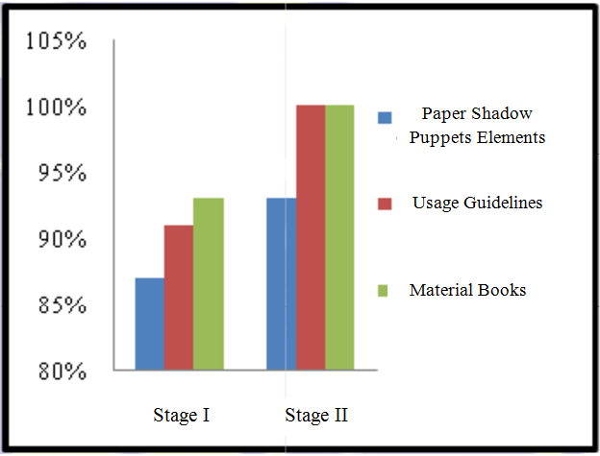

Figure 1. Comparison of Stage I and Stage II Media Expert Validation Results

In the material expert validation, the questionnaire instrument contained aspects of the material study and language study. Indicators in the material studyconsist of conformity toCore Competencies and Basic Competencies, objectives, and material elaboration for each material indicator. Another case with indicators in language study emphasizes the use of sentences for each material delivered in the material book.

Material expert validation was divided into two stages, with the results of the first stage material validation of 77% with feasible criteria. In this stage I validation, several notes were found including the learning objectives not yet attached in the material book, and indicator KD 3.7class XI Indonesian History can be developedfurther.

After the revision to the notes in stage I, the average of material experts’validation in phase II has increased and obtained results of 98% with very feasible criteria.

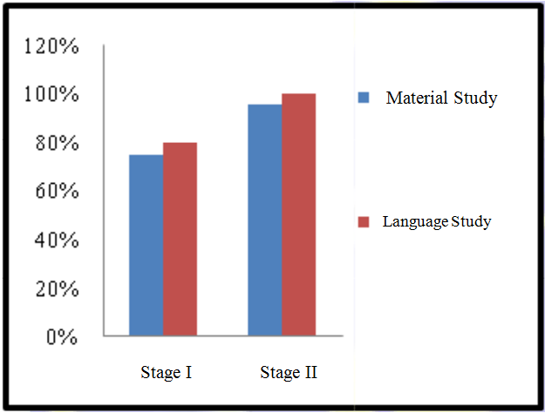

Figure 2. Comparison of Stage I and Stage II Material Expert Validation Results

1. **Feasibility of Paper Shadow Puppets as a Media for History Learning in High Schools According to History Teachers and Students**

The validation of the paper shadow puppet feasibility conducted on the subject of teachers and students includes aspects of the paper shadow puppet aspects, material books, usage guidelines, material studies, and also language studies. Validation of feasibility by teachers and students is carried out by limited sample product tryoutand application tryout as the final tryout in the research and development of this paper shadow puppet.

The subject of the paper shadow puppet tryout is class XI BB SMA N 4 Magelang. Class XI BB was chosen to be the subject of research because the class has a diverse character of students. Such as, the character that reflects the ability to solve problems, the ability to speak in public, activeness, and other characters.

At the product tryout stage, validation is only done on a limited sample by selecting 8 random students who serve as validators to assess the feasibility of paper shadow puppets as a media of historylearning. Students also assess how the paper shadow puppet works with the role playing method and the conformity of the material with the media used.

The results of validation in product tryout stage are history teachers give 88% validation in the very feasiblecriteria, and the results of the validation of 8 students is 87%. At this stage, researchers found several deficiencies both in thelearning implementation and the media developed.

The deficiencies found in the product tryout stage include the cutting of paper shadow puppets that are not neat, the use of back sound to replace the role of *gamelan* music is still less audible due to limited speaker facilities, the *kelir*replaced with a projected background not yet maximized in its operation, students do not fully understand the usage technique of paper shadow puppets with the role playing method.

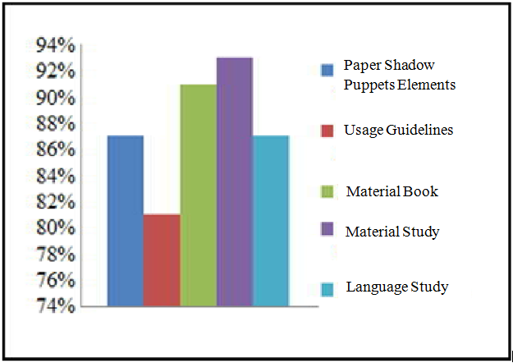

Figure 3. History Teacher Validation Results on Product Tryout Stage

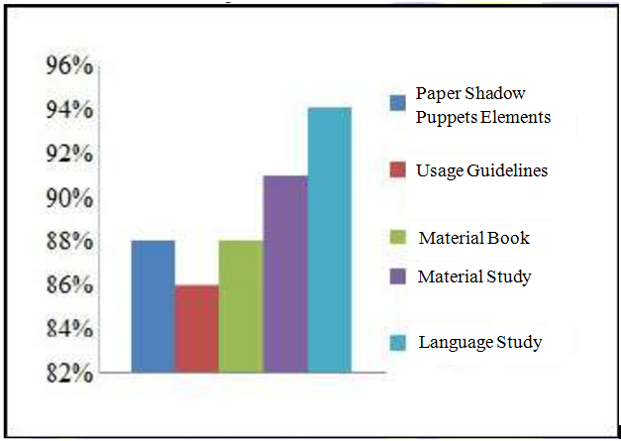

Figure 4. Students Validation Results on Product Tryout Stage

The application tryout stage is the last stage in the development of paper shadow puppets which are carried out in the same class, but with a broader subject. This is done to determine differences in the feasibility results whether there is an increase or not, and whether paper shadow puppets are suitable for use as a mediafor historylearning or not.

The validation results of history teachers and students at the stage of application tryout use with the subject of teachers and 31 students, get the results of the history teacher validation of 94% with very feasible criteria, and 93% for the validationby the students with very feasible criteria. At this stage, paper shadow puppets are declared suitable for use as a media for history learning in high school.

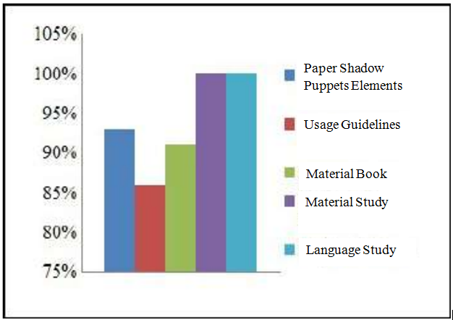

Figure 5. History Teacher Validation Results on Application Tryout Stage

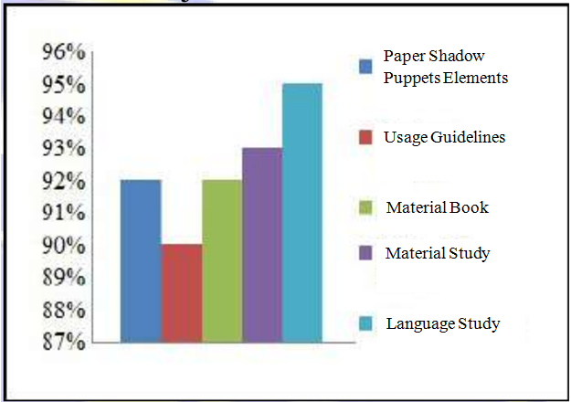

Figure 6. Students Validation Results on Application Tryout Stage

1. **CONCLUSION AND RECOMMENDATION**
2. **Conclusion**

The development of paper shadow puppets as a media for history learning in high school is implemented in class XI BB of SMA N 4 Magelang and taking KD 3.7 and 4.7 of Indonesian History. This paper puppet product passes the following stages 1) potential and problems, 2) data collection, 3) product design, 4) product validation, 5) product revisions, 6) product tryout, 7) product revisions, and 8) application tryout.Validation of media feasibility is carried out by media experts, material experts, history teachers, and students.

Based on the results of the stage I media expertsvalidation on paper shadow puppets as learning media, the results obtained an average of 90% and classified as very feasible criteria with revision. In the stage II media experts’validation, the average feasibility of paper shadow puppets reached 98% with criteria very feasible to use.

The results of stage I material experts validation showed an average of 77% with feasible criteria with revisions. Improvement in the results of material feasibility also occurred in the stage II material expert validation, so that it could reach an average of 98% with very feasible criteria, and ready for use in the product tryout stage.

The result of the history teacher validation at the limited sample product validation is 88% with very feasible criteria. While the average student’svalidation for all aspects are 87% with very feasible criteria, with revisions. At the application tryout stage where the subject’s scope is wider, the results of the history teacher’s validation show an average of 94% with very feasible criteria, and 93% from students with very feasible criteria. Thus, paper shadow puppets are declared suitable for use as a media for history learning in high school.

1. **Recommendations**

Recommendations that are in accordance with the results of the feasibility of paper shadow puppets as a media for history learning in high school are as follows.

1. For students, it is expected to become media that can facilitate understanding of the proclamation of Indonesian independence and its meaning for the Indonesian Nation. In addition, students’ interest in history is expected to increase
2. For history teachers, it is expected to become one of the choices of interactive learning media. History teachers can also modify and perfect paper shadow puppets according to student’s character.

**REFERENCES**

**Books, Journals, and Research Results**

1. Abdul Gafur. (2012). *Desain Pembelajaran, Konsep, Model, dan Aplikasinya dalam Perencanaan Pelaksanaan Pembelajaran*. Yogyakarta: Ombak.
2. Ardian Asyhari dan Helda Silvia. (2016). “Pengembangan Media Pembelajaran Berupa Buletin dalam Bentuk Buku Saku Untuk Pembelajaran IPA Terpadu”. *Jurnal Ilmiah Pendidikan Fisika Al-BiRuNi 05 (1) (2016)*. Hlm. 1-13.
3. Brian Garvey dan Mary Krug (2015). *Model-model Pembelajaran Sejarah*. Yogyakarta: Ombak.
4. Cepi Safruddin Abdul Jabar, dkk. (2016). *Manajemen Pendidikan*. Yogyakarta: UNY Press.
5. H E Mulyasa. (2014). *Pengembangan dan Implementasi Kurikulum 2013*. Bandung: Remaja Rosdakarya.
6. Imas Kurniasih dan Berlin Sani. (2017). *Lebih Memahami Konsep dan Proses Pembelajaran, Implementasi & Praktek dalam Kelas*. Jakarta: Kata Pena.
7. Irwan Gigih Juniarto. (2017). “Keefektifan Media Wayang Kertas Terhadap Aktivitas dan Hasil Belajar Menyimak Cerita Kelas V SD Negeri Moyonglor 01 Kabupaten Jepara”. *Skripsi*. Semarang: Jurusan Pendidikan Guru Sekolah Dasar Fakultas Ilmu Pendidikan Universitas Negeri Semarang.
8. Nyoman Kutha Ratna. (2014). *Karya Sastra, Seni, dan Budaya dalam Pendidikan Karakter*. Pustaka Pelajar.
9. Rizem Aizid. (2013). *Atlas Pintar Dunia Wayang*. Yogyakarta: Diva Press.
10. Sugihartono. (2016). *Psikologi Pendidikan*. Yogyakarta: UNY Press.
11. Sugiyono. (2016). *Metode Penelitian Pendidikan, Pendekatan Kuantitatif, Kualitatif, dan R&D*. Bandung: Alfabeta.
12. Supriyadi. (2015). Mengajar. Yogyakarta: Cakrawala Ilmu.

|  |  |
| --- | --- |
|  |  |