SHARI’AH GOVERNANCE DISCLOSURE INDEX: AN IDEAL INDICATOR FOR ISLAMIC FINANCIAL INSTITUTIONS

Nur 'Ain Syahirah Shaharuddin1, Memiyanty Abdul Rahim2,

{ainsyahirah70@gmail.com1, memiyanty@uitm.edu.my2}

Universiti Teknologi MARA1,2

**Abstract.** The purpose of this study is to develop the index of Shari’ah governance disclosure for Islamic Financial Institutions (IFIs) especially Islamic banks in Malaysia. The checklist is used for content analysis which derived from the text in annual report of Islamic banks to find the total index scoring of disclosure. In developing the Shari’ah Governance Disclosure Index (SGDI), the study has adopted and adjusted from the SGDI of prior studies. Measurement of index is established from frameworks of Shari’ah Governance Framework 2011 and Shari’ah Governance Policy Documents 2019 by Bank Negara Malaysia. The argument for this study is that disclosure of Islamic banks should have their own unique index according to adopted frameworks of their own organizations. Hence, it is important to develop SGDI to ensure the Shari’ah compliance in the organizations. The SGDI is very useful for future studies on checking the level of disclosure among Islamic financial institutions (IFIs).

**Keywords:** Shari’ah Governance, Disclosure, Index, Indicators

**1 Introduction**

The growth of Islamic Financial Institutions (IFIs) has shown tremendous development over the last two decades due to strong demands by consumers from Muslims and non-Muslims especially in Middle East and Southeast Asia. The Islamic Financial Institutions must adhere to Shari’ah principles. The organizations need to conforms Shari’ah principles wholly to ensure Shari’ah compliance. Shari’ah compliance means all the operations, transactions and products must be performed in accordance to Shari’ah rulings. The basic underlying principles of Shari’ah rulings in Islamic Financial Institutions must be free from elements such as interest-based *(riba‘),* uncertainty *(gharar)* and gambling *(maysir).* These elements are prohibited in Shari’ah rulings as stated in *al Quran* and *Sunnah*. Any transactions, processes or operations within organizations that have these characteristics will be considered as non-Shariah compliant.

As Islamic finance industry has been based on underlying principles of Shari’ah compliance which focus on profit-sharing and fairness. In order to strengthen these principles, Shari’ah governance are comes into effect which essential to ensuring the stability of Islamic financial system. Shari’ah governance does not have specific definition but the purpose is ensuring compliance with Shari’ah rulings in business operations. A good control of compliances with Shari’ah rules and principles has led to sustainable growth in the long run. Besides, Shari’ah governance is a cornerstone to enhance the compliance and a good frameworks will help to attain the objective.

Shari’ah governance framework has been established to guide in terms to ensure the structured, transparency of report, and disclosure of information in order to reinforce strict adherence towards Shari’ah principles. Central Bank of Malaysia or Bank Negara Malaysia has developed Shari’ah Governance Framework (SGF) in 2011 for local Islamic banks to follow it accordingly when disclosing the information to the public through annual report. The framework purpose is to ensure the effective independent oversight, responsibility and accountability of management, Board and also Shari’ah Committee. It also acts as a guidance to comply with Shari’ah principles all the time. Next, Shari’ah Governance Policy Document (SGPD) 2019 are issued by Central Bank of Malaysia or Bank Negara Malaysia to improve the Shari’ah Governance Framework 2011 with the purpose to strengthen Islamic Financial Institutions (IFIs) and enhancing more effective Shari’ah governance which integrated with business and risk strategies.

The number of risks existed such as Shari’ah non-compliance risk, liquidity risk, credit risk, reputational risk, and others. More risks exist due to the growing scale and complexity of Islamic financial industry. One of it Shari’ah non-compliance risk that is uniquely for Islamic finance industry. This risk occurs due to Islamic Financial Institutions or organization failure in complying with Shari’ah governance as provided and an event that occurs through daily operations such as transaction process, documentation, and terminology. Therefore, to check the compliance of Shari’ah within organization, Shari’ah Governance Disclosure Index (SGDI) is indeed necessary.

The issue of Shari’ah non-compliance is due to Islamic Financial Institutions exposed to the inadequate supervision, governance and best practices. This resulted to mistakes occured when dealing with Islamic finance transactions such provides interest-based like (riba‘) or existence of defect in essential elements in contract and thus, led the contract to void. Such in the case of Shamil Bank of Bahrain provide Murabaha contract for Beximco Pharmaceuticals but did charged interest even though it is unlawful.

The other issue is lacking in prior studies especially on Shari’ah Governance Disclosure Index that used framework by Central Bank of Malaysia or Bank Negara Malaysia. Most prior studies used AAOIFI Disclosure Index or Corporate Governance Disclsoure Index (CGDI). However, not every Islamic Financial Institutions (IFIs) adopt AAOIFI governance framework. Most companies has used local frameworks or their own unique Islamic governance. For the case of Islamic Financial Institutions in Malaysia which only adopted frameworks established by Bank Negara Malaysia which are Shari’ah Governance Framework 2011 or Shari’ah Governance Policy Documents 2019, new Shari’ah Governance Disclosure Index based on these frameworks is needed. Therefore, developing Shari’ah Governance Disclosure Index is necessary. The aim of this study is to develop the ideal Shari’ah Governance Disclosure Index for Islamic Financial Institutions (IFIs).

**2 Literature Review**

**2.1 Shari’ah Governance Framework 2011**

Bank Negara Malaysia has initiated a new framework of Shari’ah Governance. The framework is effective as at 2011. Shari’ah Governance Framework also provides model structures of roles, functions and reporting channels in an organization [1], [4]. Shari’ah Governance Framework has six sectors altogether [2]. The sector sometimes called as dimension or mechanism. First section, general requirements of the Shari’ah Governance framework. In this section, it summarizes the requirements for an organization to delineate the key functions or key roles of every member in enhancing the effectiveness of framework such as sketch the reporting channel in the organization and other [3].

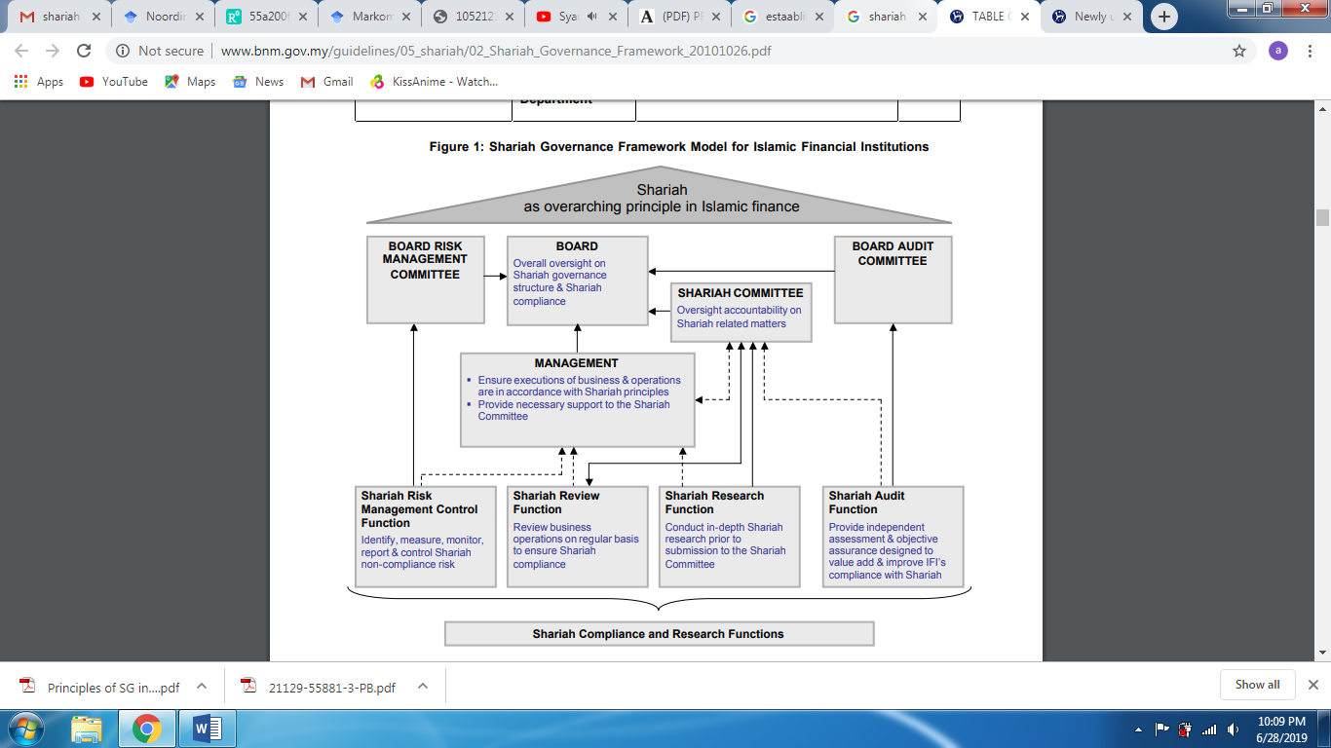

**Figure 1**: Shari’ah Governance Framework Model

Source from: Shari’ah Governance Framework Model for Islamic Financial Institutions Bank Negara Malaysia [4]

Through Figure 1, Shari’ah governance framework requires each part of key organs of persons which comprises of following to run the operation smoothly:

1. *Shari’ah Board* [2], [3] which oversight all of the Shari’ah compliance and also Shari’ah structure, the Board is responsible to oversee all of the aspects of Shari’ah compliance in Islamic banking operations. Board must construct and establish a good Shari’ah governance and expected to understand Shari’ah compliance.
2. *Shari’ah Committee* [2], [3] must have qualified members whom can solve the Islamic financial issues that arisen in the organizations. Overall, every Islamic banking need to have Shari’ah Committee whom have a proper qualification and experience in Shari’ah.
3. The *effective management* [2] whom will responsible to ensure the proper execution should be done to ease the operation of business and also accordance to Shari’ah compliance. Management also need to provide any necessary support towards every function when they need it.
4. *Shari’ah review function* [2], [3], [6] needs to review business operation internally on daily basis accordance to Shari’ah compliance. If any negligence occurs, this function will directly inform to the Shari’ah Committee and indirectly to management to solve the issues.
5. *Shari’ah audit function* [2], [3], [6] needs to provide independence assessment in ensuring the assurance of business operation complying with Shari’ah. The assurance can add value and improve the Islamic banking operations.
6. *Shari’ah risk management* controls function responsible for identifying, assessing, monitoring, controlling and reporting any possible Shari’ah non-compliance risk which will arise.
7. *Shari’ah research function* will develop in-depth research focus on Shari’ah compliance submission in a true way.

The second section is oversight, accountability and responsibility. Organization needs to disclose information to enhance the level of accountability and responsibility [2], [3] that anticipated by each member of the Board of directors, Shari’ah Committee and management in Islamic banking. Each key function need to clarify its role in performing diligent oversight to ensure the accountability.

Third section focus on independence. This section purpose to protect the independence of the Shari’ah Committee in providing sound Shari’ah decision-making and exercising their duties to make judgement in an objective manner [2], [3]. Modification without consent by Shari’ah Committee should be set aside. All of decisions need to be recognized by IFIs.

Fourth section relates to competency [3], which focuses on requirements and contemplated competency for key organs to be capable of implementing a good Shari’ah Governance in daily operation. Thus, the consistency can be controlled.

While, fifth section revolves around confidentiality and consistency, it outlines the minimum set of rules that will prioritize of observing and protecting the confidentiality, while refining the level of consistency in decision-making by the Shari’ah Committee. Thus, to ensure no loophole will arise and affect the whole operation.

The last section highlights on Shari’ah compliance and research functions. Imposing the functions for Shari’ah review, Shari’ah audit, Shari’ah risk management and Shari’ah research. By having these functions, company can have more assurance and enhance a better business operation by improving any problems.

The gap in Shari’ah governance which is Shari’ah Board responsibilities has specifically focus on oversee the operational details associated with products while Shari’ah Board should oversee the overall process comply with Shari’ah [7].

**2.2 Shari’ah Governance Policy Document 2019**

Bank Negara Malaysia has issued Shari’ah Governance Policy Document (SGPD 2019) on 19 September 2019. However, the effective date for the new policy is on 1 April 2020 with the exception on paragraph of 12.5 which will come into effect on 1 April 2023. Bank Negara Malaysia has issued this new policy pursuant to Islamic Financial Services Act 2013 (IFSA 2013) and Development Financial Institutions Act 2002 (DFIA). This new policy document is replacing the old Shari’ah Governance Framework 2011, paragraph 11.4 of Financial reporting for Islamic banking institutions, paragraph 10.4 of guidelines on financial reporting for development financial institutions and also paragraph 13.5 of financial reporting for *Takaful* operators [5].

The policy is divided into six main parts or known as dimension or else mechanism which are highlighted in Shari’ah governance policy documents 2019 including the Board of directors, the Shari’ah Committee, the senior management, control functions, Shari’ah compliance culture and remuneration, and lastly, transparency and disclosures. These main parts also slightly differ from the previous version of Shari’ah governance framework which taken effect in 2011 with independence, competency, confidentiality and consistency are no longer as part of the main arrangements.

The first highlighted part is the Board. In the policy, Bank Negara Malaysia has stated key responsibilities of the Board in promoting sustainable growth for Islamic financial institutions and also in enhancing financial soundness must be dealt with institutionalize of Shari’ah governance framework through corresponding the size, complexity and nature of the organizations. Roles such approving the policy to enhance good governance structure, reporting quality and Shari’ah compliance by establishing Shari’ah non-compliance risk management. The Board also needs to oversee the implementation of decisions and advices which must be aligned with Shari’ah governance objectives by Shari’ah Advisory Council, Shari’ah Committee, and functional lines, and if there any potential risk implications from the implementation that could resulted in Shari’ah non-compliance. This is to promote sound corporate culture while adhering to Shari’ah compliance in every aspect within the Islamic financial institutions. Directors also need to continuously upgrade their knowledge, skills and understanding on Islamic finance. The Board also need to emphasize their communications with the Shari’ah Committee.

The second arrangement is Shari’ah Committee whom plays an important role in providing sound advice to the Islamic financial institutions through ensuring Shari’ah compliance in aims, operations, business, affairs and activities of the organization. The policy document clearly outlined the key responsibilities of Shari’ah Committee as a guideline to perform duties. In decision-making process, Shari’ah Committee must take consideration of risk practices and any relevant business to enhance the soundness of decision-making. This is because Shari’ah Committee are accountable for every advice or decision made by them [8]. Therefore, any possible or relevant business must be considered to avoid mistakes from happen. Although decisions are made by them, Islamic financial institutions must deliberately record the decisions and advices include rectification of any Shari’ah non-compliance issues found in operation of the organization. As Shari’ah Committee need to give independence advices, each member must disclose the interest that could trigger conflict of interest. Bank Negara Malaysia highlighted important parts in Shari’ah Committee which are Shari’ah Committee meetings, appointment, cessation and disqualification, composition of Shari’ah Committee, and secretariat to the Shari’ah Committee.

Next highlighted part is senior management. Senior management whom directly involved with operation of Islamic financial institutions also play important roles in ensuring Shari’ah compliance culture within the organizations. Thus, Bank Negara Malaysia decided to outlay key responsibilities of senior management for this purpose. Senior management is led by Chief Executive Officer (CEO) of an organization whom responsible over daily basis operation and management. Daily basis operation such affairs, business and activities must comply with Shari’ah at all times. Therefore, CEO and senior management need to develop a good management structure in order to create effective reporting channel within an organization which reinforce sound understanding of Shari’ah matters. This is to amplify the accountability between business lines and the internal control functions. Senior management also needs to execute good Shari’ah governance, policies, procedures and practices, and any rulings from Shari’ah Advisory Council (SAC) or follow Shari’ah Committee’s advice. mmittee in establishing Shari’ah compliance culture within Islamic financial institutions.

Fourth, control functions within Islamic financial institutions must help in creating Shari’ah compliance culture. The effective management from Shari’ah risk management, Shari’ah review and Shari’ah audit are established to avoid any potential Shari’ah non-compliance risks arise. In spite of the establishment of effective management, a comprehensive and integrated approach of enterprise-wide risk management is also important. This is to oversee the Shari’ah governance through risk management, compliance and internal audit in a structured way. Therefore, all business lines involved in managing Shari’ah non-compliance risk must be easily accessible for control functions. Besides, Shari’ah non-compliance culture can be achieved with each member of control functions having adequate knowledge and experience in Islamic finance.

Shari’ah risk management specifically focuses on managing possibility or real occurrence of Shari’ah non-compliance in the operation of the Islamic financial institutions. The management at least needs to identify if there is any possibility of Shari’ah non-compliance risk exposure in Islamic banking. Shari’ah non-compliance risk means that any activity that contradicting with Shari’ah beliefs especially related to IFIs such as occurrence of *riba’*, *gharar* or uncertainty, *maysir* or gambling and transaction that involves with these prohibited things. Second, measure the level of impact of the Shari’ah non-compliance risk exposure towards the business and operations in Islamic financial institutions (IFIs). It means calculate the risk exposure whether it will cause big or small damage to the IFIs in overall operation. Next, drafting and establish the risk mitigation to suppress the damage of the Shari’ah non-compliance risk. Then, the company needs to apply the risk mitigation for Shari’ah non-compliance risk exposure and observe to check the effectiveness of risk mitigation in minimizing the damage. The last stage that the Shari’ah risk management needs to be aware is to report the results of observation to the Board, Shari’ah Committee and senior management.

Besides, Shari’ah review also part of Shari’ah control function that important as other control function. Shari’ah review function responsible in conducting regular assessment to review the compliance with Shari’ah on IFIs including operations, business, transactions, affairs and activities. As Shari’ah risk management function, Shari’ah review also need to perform stages such as identify, assess and monitor the Shari’ah compliance. Next, report regularly to the Board, Shari’ah Committee and senior management on the findings or any existence of Shari’ah non-compliance in the IFIs. Person who performs this also need to update on the latest developments that related to Shari’ah compliance such as new regulatory framework or statute from Bank Negara Malaysia. Not only that, Shari’ah reviewer also responsible to provide sufficient training and guidance to the officers, the Board, the Shari’ah Committee and senior management. Good understanding in Shari’ah knowledge will help the Board, senior management and employees to behave accordingly in Shari’ah context. Officers who perform the Shari’ah review function must be qualified and have great understanding in Shari’ah related matters especially in IFIs.

Next, other control function that plays important roles in IFIs operations, business and activity is Shari’ah audit. The purpose of Shari’ah audit function is to measure the effectiveness of the IFI’s internal control system, risk management system altogether with Shari’ah compliance in business, transaction, operation and also activities in the Islamic banking. The basic or minimum task that Shari’ah audit function requires to perform is construct good audit methodology that helps to assess risk exposure for each respective audit area effectively. Thus, sketch audit plan in order to assign audit task to the person in charge. Developing audit program that will guide internal auditors when performing audit. The audit program will assist internal audit especially when it comes to gather information needed, audit procedures and perform audit assessment. Later, internal auditors will communicate to the Board and Shari’ah Committee regarding the results, findings and recommend rectification measures through platform such as audit report and other.

Besides that, the fifth arrangement that been highlighted in the SGPD 2019 is Shari’ah compliance culture and remuneration. IFIs are encouraged to promote Shari’ah compliance culture thoroughly from its aims, operations, transactions, business and until its activities. Shari’ah compliance culture means widely applying Shari’ah applications in the operation of IFIs [9]. IFIs need to ensure every person in the IFIs are applying Shari’ah concept in business practices and also the behavior which includes senior management and also employees [5]. No persons shall be excluded. The Board and senior management promote behavioral norms of Shari’ah compliance and also adopting the ‘tone from the top’ that regularly communicate and integrate Shari’ah principles in the business strategies, internal policies and risk appetite. In order to create Shari’ah compliance culture within the IFIs, effective communication policy is necessary. Good behavior from the senior management certainly will encourage the good morale among employees in IFIs.

Aside from effective communication policy, remuneration is one of the ways that help to reinforce the Shari’ah compliance culture. Incentive framework is prominent feature to promote the culture. Even, most Islamic banking also introduced penalty and reward systems in measuring the performance which related to Shari’ah compliance [9]. These systems are helpful in disciplining and motivating employees to practice Shari’ah-compliant in every aspect as well as daily tasks. Through this remuneration system also helps to avoid possible risk that most likely will occurs within IFIs, as employees shifting their focus to be rewarded and get remuneration through behaving well. Therefore, it will strengthen the risk culture among employees.

The last section that been highlighted in SGPD 2019 are transparency and disclosure. This part focus on disclosures should have made by the Board and Shari’ah Committee in the annual report according to paragraph 22.1. Paragraph 22.1(a) stated IFIs should ensure that the Board disclose its oversight accountability of implementation for Shari’ah governance within the operation and complying with Shari’ah rulings related to IFIs. Hence, Shari’ah Committee need to disclose its responsibilities in annual report which relates to Shari’ah governance and state the independent view on Islamic banking’s compliance towards Shari’ah which been highlighted in paragraph 22.1 (b). The view must not be influence by other parties related to the Islamic banking that the member served. The independent view is necessary to avoid interference from management. As in accordance to paragraph 22.1 in SGPD 2019, disclosure need to be prepared together with annual report from IFIs. Local Islamic financial institutions may publish their annual report on its website. However, foreign branch whom IFIs that operate in Malaysia need to be submitted to the Bank Negara Malaysia.

Further, IFI need to ensure that the Board also will disclose its roles, responsibilities and accountabilities just like Shari’ah Committee clearly without any misleading information, false, inaccurate or incomplete information in annual report. The disclosure by Shari’ah Committee need to be signed by at least two Shari’ah Committee members in relation to paragraph 22.1 (b). As Shari’ah Committee needs to provide independent view, in order to achieve this, IFIs must construct a written policy that can be used by Shari’ah Committee. This written policy should be checked and approved by the Board beforehand. The purpose of the written policy is to ensure that the Shari’ah Committee give high quality independent view on IFI’s compliance with Shari’ah which has been undertaken through effective and structured process in the written policy. In the written policy, IFIs should considered several aspects to maximize the effectiveness of written policy to Shari’ah Committee. There are five aspects that need to give attention when forming opinion of Shari’ah Committee which are planning and includes the determination of materiality, obtaining evidence if find any transaction that deems to be Shari’ah non-compliant, consult Shari’ah Advisory Council (SAC) related to uncertain information details, then forming opinion matters related to IFI’s compliance to Shari’ah and lastly, the manner in which the opinion should have established.

Shari’ah Committee’s opinion on IFI’s compliance with Shari’ah rulings can be expressed such when members believe that there is no evidence that the IFIs have involved with any transaction, activity, operation, business, or affair that is non-compliance with Shari’ah rulings for IFIs. The member need to disclose that the overall operation within IFIs are complying with Shari’ah and no occurrence of Shari’ah non-compliance has existed. However, if there is occurrence then the members should disclose that it has been rectified or in the process of being rectified. Paragraph 22.10 in SGPD 2019 emphasized that the occurrence of Shari’ah non-compliance event must be reported clearly with the nature of the events, reason of the occurrence, status and any measure undertaken to rectify it. The reason is to assure that IFIs are far from involved with the non-compliance activity that will astray from the aim and objectives of the IFIs that overall operations must be based on Shari’ah compliance.

**3 Methodology**

**Developing the Shari’ah Governance Disclosure Index (SGDI)**

As explained above, both frameworks or guidelines which are Shari’ah Governance Framework 2011 and Shari’ah Governance Policy Dicuments 2019 established by Bank Negara Malaysia were chosen because these frameworks are effective to be adopted as the latest governance frameworks for Islamic Financial Institutions especially in Malaysia. The frameworks are based on GP8-i (Guidelines on Financial Reporting for Licnesed Islamic Banks) and IFSA guidelines that list out elements that related in emphasizing Shari’ah matters among Islamic banks and acceptable to be used for Islamic banks. In developing the index, there are several stages or process of construct the Shari’ah Governance Disclosure Index (SGDI).

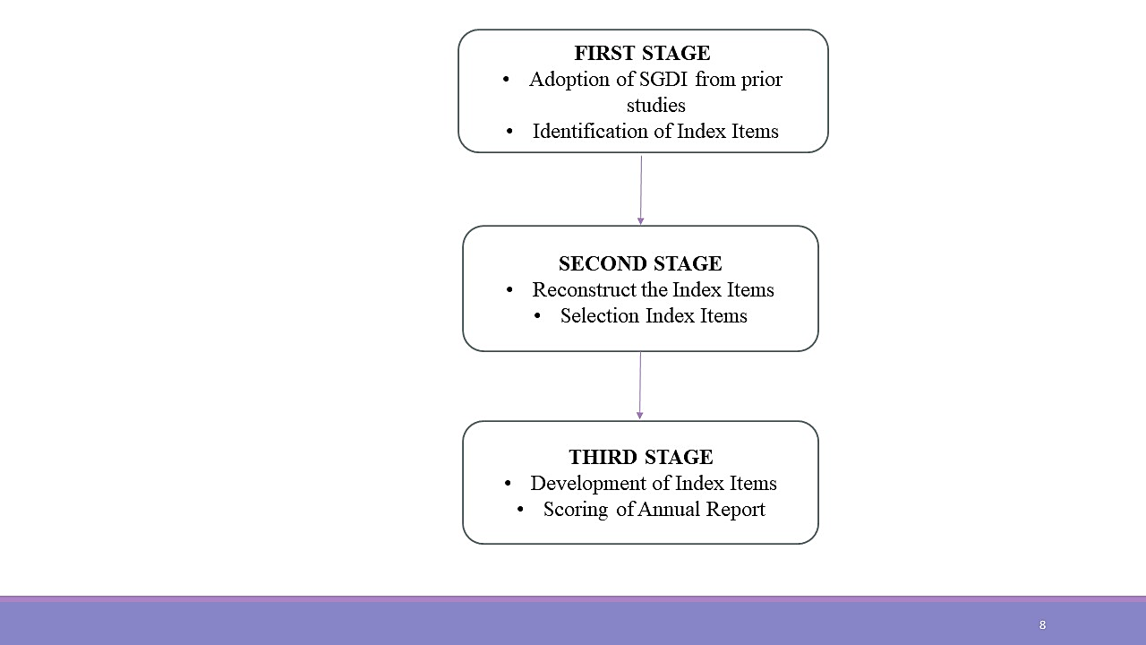

**Figure 2:** The three stages in developing the Shari’ah Governance Disclosure Index (SGDI)

As shown in the Figure 2, there were three phases in order to develop the Shari’ah Governance Disclosure Index. The stages are as follows:

First Stage: Identification of potential items need to be discclosed from adoption Shari’ah Governance Disclosure Index (SGDI) of prior studies and also based on both frameworks made in reference to the recommendations from Malaysia which are Shari’ah Governance Framework 2011 and Shari’ah Governance Policy Documents 2019.

In this stage, the approach taken is by considering SGDI sample [10] that based on reference of Shari’ah Governance Framework 2011, Islamic Financial Services Act (IFSA) and GP8-i (Guidelines on Financial Reporting for Licensed Islamic Banks) which have five (5) themes or dimensions and 37 items need to be disclosed in annual report. It focused on SGD checklist for Islamic banks only. The prior study’s checklist outline the Shari’ah governance practice information and to act as a guidance in developing the new checklist which suitable for all types of Islamic Financial Institutions (IFIs) whether Takaful companies, Islamic banks or Islamic Investments Institutions.

Then, in order to increase the accuracy of Sharia’ah governance information, identifcation of potential items to be disclosed and themes are done based on both frameworks of Shari’ah Governance Framework 2011 and Shari’ah Governance Policy Documents 2019. The purposes are to enhance the governance regulations especially for Islamic Financial Institutions (IFIs) in Malaysia and to check level of compliance in every institution.

The identification of potential items from the Shari’ah Governance Framework 2011 has found six (6) main themes with four (4) sub-themes included general requirements, oversight accountability and responsibility, independence, competency, confidentiality and consistency, and Shari’ah compliance and research functions. Four (4) sub-themes are Shari’ah audit, Shari’ah risk management, Shari’ah review and Shari’ah research. Meanwhile, for Shari’ah Governance Policy Documents 2019 found six (6) themes of the Board of directors, the Shari’ah Committee, the senior management, Shari’ah control functions, Shari’ah compliance culture and remuneration, and the last transparency and disclosures [10].

Second Stage: Reconstruct the disclosure to suit the organization and selection items fr checklist.

Reconstruct is needed for disclosure items to improve the existing checklist of prior studies [10] and adopt the identified items based on both frameworks by Central Bank of Malaysia or Bank Negara Malaysia especially SGPD 2019 as it replaced the SGF 2011. The latest version has established to improve the risk management.

Through reconstructing, any disclosure items that is not suitable for Shari’ah Governance Disclosure Index (SGDI) which mostly items related to GP8-i (Guidelines on Financial Reporting for Licensed Islamic Banks), as the purpose to develop the SGDI especially for Islamic Financial Institutions not only Islamic banks. This is to ensure the SGDI can be use for many institutions. Aside from that, adding disclosure items that are suitable to be adopted by Islamic Financial Institutions.

Selection Items to be disclosed are important to avoid redundancy happened when developing Shari’ah Governance Disclosure Index. The frameworks has 14 themes or dimensions found after identification of both frameworks. The possibility of having the same items or the themes are higher. Example general requirements of key persons in the SGF 2011 is also mentioned in SGPD 2019 where in each theme has stated on importance of key persons, Shari’ah commitee’s theme of SGF 2011 also stated as Shari’ah committee’s in SGPD 2019, and Shari’ah compliance functions which has Shari’ah review, Shari’ah risk and Shari‘ah audit also mentioned in both frameworks of SGF 2011 and SGPD 2019. These items or themes that has the same meaning will be consolidated into one (1) items of governance information. Therefore, to avoid redundancy as these issues, selection of items are carefully made and reviewed.

Third Stage: Developing final index items and also scoring annual report.

The last stage is to ensure all the recommendations in the guidelines were taken into account and check if there is any duplication of the same items been made after assign the relevant items under other dimensions or themes to be adopted for part of final index. In the last stage in developing final index items, if there are any overlapped items will be deleted accordingly.

Through these stages, overall of five (5) themes or dimensions were created which are T(1) Shari’ah committee, T(2) Shari’ah review, T(3) Shari’ah audit, (T4) Shari’ah risk, and (T5) transparency and disclosure.

Then, the scoring of annual report will be performed with assigning one (1) points if organization‘s disclose the items they need to in annual report. If no disclsoure been made, therefore zero (0) points will be assigned accordingly and effectively. The total index items for SGDI are 50 index items to be disclosed by IFIs.

**4 Findings**

The final comprehensive SGDI consists of 50 items divided for five (5) themes or dimensions unevenly. The findings only focus on key persons that help to enhance and improve compliance level of Shari’ah rulings.

The 50 items shows Table 3 shows Shariah Commitee‘s dimension or theme as first theme focus on the sub-items has 18 items relating to competency of members such qualification and experience regards to Islamic finance that are needed to be part of the committee. The responsibilities and duties of Shari’ah Committee’s members to provide report, give independent view, provide disclosure of Shari’ah matters or non-compliance, and accountable for their own decisions. Also, the composition of the Shari’ah Committee and disclosure of meeting that need to be attend by Shari’ah Committee.

The second theme or dimension is Shari’ah review has five (5). The sub-items for this theme are responsibilities and duties of members for Shari’ah review. The process to review Shari’ah matters in Islamic Financial Institutions‘ operations by members. Besides, the communication policy of Shari’ah review to enhance the effectiveness of Shari’ah review ito comply with Shari’ah rulings.

The third theme is Shari’ah audit that has six (6) items that need to be disclosed in annual report in Islamic Financial Institutions (IFIs). The sub-items for this theme focus on responsibilities and duties of internal audit in process of auditing the operations of Islamic Financial Institutions (IFIs) regarding the Shari‘ah governance. Qualification, knowledge and competency of members of internal audit.

The fourth theme is Shari’ah risk. There are five (5) items need to be disclose under this theme. The theme is related to risk management specifically in Shari’ah risk. Shari’ah non-compliance risk is a unique risk in Islamic finance industry that need to give attention on. The process to facilitate the Shari’ah risk, provide the mitigation measures to manage the risk. Communication policy between the members to the key persons.

The last theme is transparency and disclosure. 16 items are outlined to be disclosed in the annual report of the organization. This theme emphasizes on the importance of disclosure especially in terms of compliance with Shari’ah, opinion of the business operation by Board, Shari’ah Committee, zakat obligations, non-permissible activities, and aim of the operation.

In the Table 3 shows the final Shari’ah Governance Disclosure Index that is ideal for Islamic Financial Institutions to measure the level of Shari’ah compliance in the organization.

**Table 3** Shari’ah Governance Disclosure Index

|  |  |
| --- | --- |
| Dimensions | Checklist Items |
| Shariah Committee | 1. Majority members are qualified and experience in Shari’ah 2. Sufficient knowledge on finance and Islamic finance 3. Independent view without any undue influence 4. Shariah Committee’s report 5. Must not be appointed from other IFI’s Shari’ah Committee (SC) 6. Composition of SC members must not less than five (5) 7. At least 1 member SC is member of the Board 8. Chairman of SC must be direct liaison with the Board 9. Accountable for view provided 10. Advice regarding Shari’ah matters 11. Endorse Shari’ah policies and procedures 12. Endorse and validate relevant documentations 13. Assess work carried out by Shari’ah Review and Shari’ah Audit 14. Disclosure number of meeting in SC 15. Disclosure no attendees in SC’s meeting 16. Number of attendees must be two-third of members with Shari’ah background 17. Meeting shall be held at least six (6) times a year 18. Each member of Shari’ah Committee must have at least 75% attendance of total meeting |
| Shariah Review | 1. Qualified Shari’ah officers 2. Review overall IFI’s business operations 3. Review documentation of the process 4. Communicate to the Board, SC and senior management on outcomes 5. Review IFI’s officers were provided with adequate training and guidelines on Shari’ah |
| Shariah Audit | 1. Provide independent assessment and objective assurance 2. Performed by internal auditors whom have Shari’ah knowledge 3. Audit of financial statement 4. Disclosure on Shari’ah compliance 5. Review Shari’ah governance 6. Conduct Shari’ah audit on periodical basis |
| Shariah Risk | 1. Performed by qualified risk officer 2. Facilitate the process of Shari’ah risk 3. Formulate and recommend risk mitigation measures 4. Report to the Board, SC and senior management 5. Develop and implement process |
| Transparency & Disclosure | 1. Disclosure of SC on responsibilities 2. Disclosure of opinion on IFI’s compliance with Shari’ah by SC 3. Disclosure of the Board on oversight accountability 4. Disclosure of opinion on IFI’s compliance with Shari’ah by the Board 5. Zakat obligations payment on business 6. Zakat obligations payment on shareholders 7. Zakat obligations on depositors 8. Profile of SC 9. Financial information 10. Aim and operation must free from Shari’ah non-compliance 11. Disclosure on Shari’ah non-compliance 12. Zakat amount 13. Involvement in non-permissible activities 14. Amount of involvement in non-permissible activities 15. Reason on non-permissible activities 16. Disclosure must be signed by not less than 2 SC members |

**5 Conclusion**

Shari’ah governance disclosure index is one of the ways to measure the compliance of the organization. Since Islamic finance industry has grown tremendously, lots of risks are found that could potentially harm the organizations. Due to this, considerable attention especially on compliance level of Shari’ah governance has make people realize the importance of the governance. Through achieving the good quality disclosure of Shari’ah governance, the business operation will be improved in terms of governance practices and transparency. Subsequently, sustainable goals are achievable in the long run.

The use of comprehensive list of disclosure items which summarizes from two frameworks by Bank Negara Malaysia which are Shari’ah Governance Framework 2011 and Shari’ah Governance Policy Document 2019 are the primary contribution of the study. Moreover, the SGDI developed in this study can be used as a benchmark to measure the quality of Shari’ah governance of Islamic Financial Institutions especially in Malaysia.

**Reference**

[1] T. Mizushima, “Corporate Governance and Shariah Governance at Islamic Financial Institutions : Assessing from Current Practice in Malaysia,” *Reitaku J. Interdiscip. Stud.*, vol. 22, no. 1, pp. 59–84, 2014.

[2] S. Miskam, “Shariah Governance in Islamic Finance : the Effects of the Islamic Financial Services Act 2013,” in *Proceeding of the World Conference on Integration of Knowledge, WCIK 2013.*, 2013, pp. 455–463.

[3] Mu. I. H. Kamaruddin, M. M. Hanefah, Z. Shafii, S. Salleh, and N. Zakaria, “Comparative Analysis on Shariah Governance in Malaysia : SGF 2011 , IFSA 2013 and SGPD 2019,” *J. Public Adm. Gov.*, vol. 10, no. 1, pp. 110–131, 2020, doi: 10.5296/jpag.v10i1.16157.

[4] B. N. Malaysia, *Shariah Governance Framework*. 2011, p. 50.

[5] B. N. Malaysia, *Shariah Governance*, no. iii. 2019, pp. 1–22.

[6] N. F. Bahari and N. A. Baharudin, “Shariah Governance Framework: The Roles Of Shariah Review And Shariah Auditing,” in *Proceeding of the 3rd International Conference on Management & Muamalah 2016 (3rd ICoMM)*, 2016, p. 8.

[7] S. A. Yussof, “The Islamic Financial Services Act , 2013 : Malaysia’s Model Framework for Shariah-Compliance and Stability,” *Islam Civilisational Renew.*, vol. 4, no. 3, pp. 391–406, 2013, doi: 10.12816/0009759.

[8] S. Mollah and M. Zaman, “Shari’ah supervision, corporate governance and performance: Conventional vs. Islamic banks,” *J. Bank. Financ.*, 2015, doi: 10.1016/j.jbankfin.2015.04.030.

[9] F. Jaafar, M. H. M. Tahir, and N. J. Ismail, “Strengthening Shariah Compliance Risk Culture,” 2018.

[10] R. Masruki, B. K. Dhar, and M. M. Hanefah, “Shariah Governance Practices of Malaysian Islamic Banks in the Light of Shariah Compliance,” *Asian J. Account. Gov.*, no. July, pp. 1–10, 2018.