STUDY OF USAGE SOCIAL MEDIA “INSTAGRAM” AMONG MILENIAL MOTHERS

Haris Annisari Indah Nur Rochimah^{1*}, Prahastiwi Utari^{2,}, Sri Hastjarjo³
^{1,2,3}Faculty of Social and Political Sciences, Universitas Sebelas Maret, Surakarta, Indonesia
¹annisari_komunikasi@student.uns.ac.id ²prahastiwi@staff.uns.ac.id ³sri.hastjarjo@staff.uns.ac.id

ABSTRACT
The need for information in the 4.0 era is no longer unstoppable. Many things in this aspect of life are very easy to find on the internet. The use of social media is one that is favored by internet users with a fairly high intensity. Social media is an alternative platform for information seekers to find references that can satisfy their motives for using the media. One of the most popular social media users today is Instagram. Researchers want to find out how the use of Instagram social media for millennial young mothers who have a tendency to be curious, anxious, and worried about their role as a young mother who recently married and has children. This forms a phenomenon of social media dependence on account information that is considered credible in meeting information needs. The question is, can the needs of millennial young mothers be met or not through Instagram. This study uses a qualitative descriptive method, with 40 young mothers who actively use Instagram as samples or informants. Data collection techniques in this study are observation, interviews. From the results of the study it can be concluded that Instagram is a social media that is able to meet one's needs, namely cognitive, affective, personal integration, social integration and fantasy (entertainment) needs.

Key word : social media, instagram, millennial mothers

- INTRODUCTION

Entering a new phase of life, including couples who have just married and then have children, certainly requires some information. The relevant information usually contains in-depth information. Relevant information is expected to answer every question that exists in every human being. The many problems present and confusion after marriage and having a baby are of course a challenge in itself for individuals who experience it. Loudon (2016) states that informational support helps mothers feel ready and confident for their new roles, and eases the transition from their parents. Mothers may consider actively that seeking information is "an important part of preparing for motherhood," and that in itself presents new challenges. Professionals lack adequate information support, both from health workers and information providers such as librarians. According to Loudon (2016) that 44 percent of mothers in Scotland reported unmet information needs during antenatal care, and 39 percent during postpartum care. Further research reported unmet information needs, particularly among young first-time mothers (primiparous). [1]
Millenials (Hasan Aksoy, 2019: 97) is the result of a theoretical reference that divides the population into several segments and can be defined by the year of birth. Millennials generation or often referred to as generation Y are included in individuals born between the birth years of 1982 and 2001. [2] This generation is a new generation who is experiencing a new phase of marriage, has just entered the phase of parenthood and is preparing everything in the future according to their plans. All their questions are formed and they try to find information through the media or people who are considered specialists in knowledge related to parenting.
According to Census Bureau data in the White House report (The Council of Economic Advisers, October 2014) Millennial mothers are mothers born in 1980-2004. The study says that 1 in 5 mothers (about 22 percent) are millennial mothers. According to the latest analysis data from the US Census Bureau, about 90 percent of the 1.5 million new mothers in the past year were millennial mothers. In other words, at least in the United States there are around 9 million millennial mothers who are currently raising children (motherandbaby.id, 2017 accessed on March 3, 2019). Based on a survey conducted by babycenter in 2018 in Figure 1, here are the characteristics of millennial mothers:

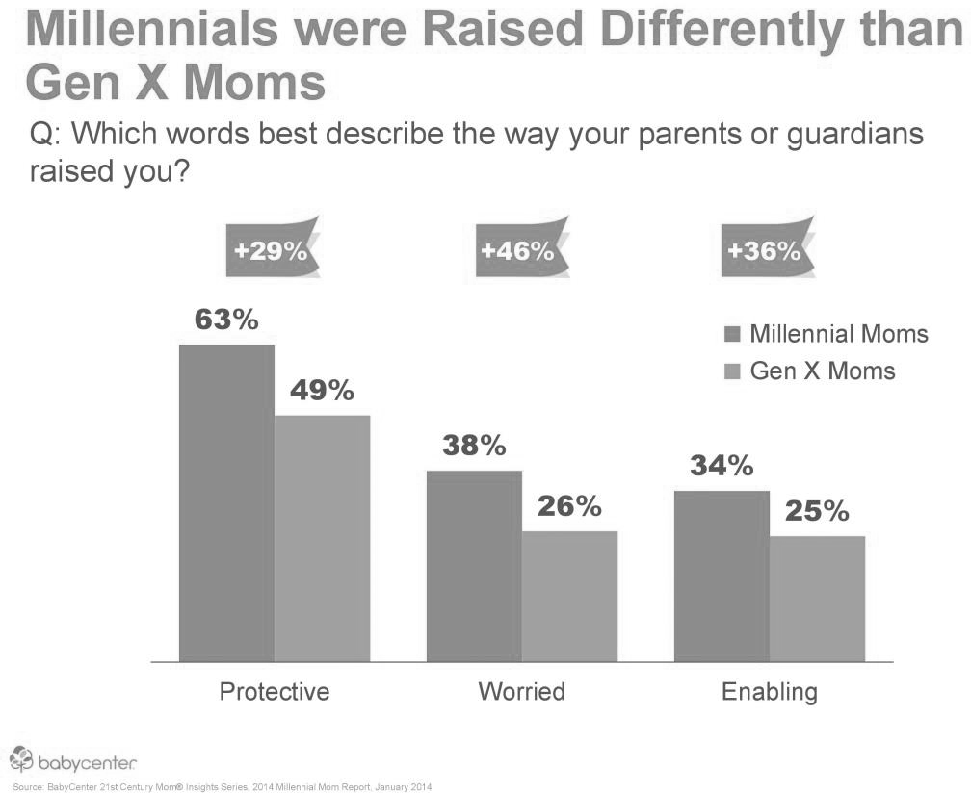

Figure 1. Characteristics of Millennial Mothers
Source: https://motherandbaby.co.id,2017

When using social media, millennial mothers carry out a number of activities as shown in Figure 2 below:

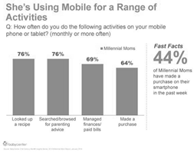

Figure 2. Millennial Mothers' Activities on Social Media
Source:https://motherandbaby.co.id,2017

The diagram image shows that millennial mothers' interest in accessing information in terms of finding recipes and parenting is quite high through digital media.
Dennis McQuail (Stephen W. Littlejohn, 175) revealed that consumers have 4 types of information accessed, namely (1) entertainment (2) information (3) personal identity (4) integration and social interaction. The choice of this type of content also applies to young mothers who have just married and have children. [3] Social media as a new media that is now very close to our lives, has a big role in shaping decisions and self-perceptions. In the end, it can cause social anxiety for its users. This social anxiety is related to the depiction of fear or worry when individuals are in certain social situations. Individuals with social anxiety will result in developing negative feelings and will predict negative things when interacting and communicating with others (DeVito, 2001).There is a link between social anxiety and social media dependence. So that individuals who have social anxiety will use this media excessively to overcome the obstacles that exist in themselves. The results of this study (Prayoga & Akmal, 2014) provide a clear explanation of the impact of social media dependence on the social life of these individuals in terms of their interpersonal functions.
Separately, another study by Soliha (2015) states that the effects of social anxiety, depression, and loneliness significantly influence the emergence of addiction to social media. Can these millennial young mothers meet their needs for information and other things they need in media via Instagram? In general, Katz, Gurevitch, and Haas believe that the typology of human needs related to media is classified into five groups: Cognitive needs (which are concerned with affirming information, knowledge and understanding of the environment); Affective needs (which answer about the experience that is felt); Personal integrative needs (i.e. needs related to trust, loyalty, and status personal); Social integrative need (this need is based on an individual's desire to be affiliated); The need for fantasy (which relates to release of tension or entertainment) (Yusup, 2009: 338-339).

- RESEARCH METHOD

This research method uses descriptive qualitative research. Bogdan and Taylor define a qualitative research methodology as a research procedure that produces descriptive data in the form of written or spoken words from people and observable behavior. This approach is directed at the setting and the individual holistically (intact). (Moleong, 2010: 4)
This qualitative method seeks to understand and interpret an event of interaction with the behavior of young millennial mothers in using the internet, especially the needs that millennial young mothers get when using Instagram. The reason the researcher uses qualitative methods is because he wants to understand in depth the needs of using Instagram social media in depth, from cognitive, affective, personal integration, social integration, and imaginary needs. The author reports the reality in the field honestly and relies on the commentary text and the informants' meaning. The author is directly related to the one being studied by observing informants in a certain period of time.
Using the descriptive method, it means that the researcher analyzes the data collected in the form of words, pictures and not numbers. The data may come from interview scripts, field notes, photos, videotapes, personal documents, notes or memos, and other official documents (Moleong, 2010: 11). The subjects of this study were 40 millennial young mothers aged 22-37 years who actively use social media Instagram.

- RESULTS AND DISCUSSION

Based on data collected from observations and interviews with 40 millennial mothers who use Instagram social media. The results can show that informants have a need to use Instagram both from cognitive needs, affective needs, personal integration needs, social integration needs and fantasies or entertainment needs.
a. Cognitive needs
The behavior of seeking information through social media on Instagram is one of the ways millennial mothers meet their cognitive needs. By using Instagram they can increase general socio-political, economic, health and also specific knowledge about parenting, fashion, beauty and culinary. If users need up-to-date information related to the required information themes, they will follow a similar account on Instagram or search using hashtags or keywords to find the information in question. If you want to know more about specific figures, such as influencers or celebrities who are concerned about maternal and child health and parenting, of course they will follow these mom influencers' accounts. One of the results of the interview from the informant said that when young millennial mothers want to know the parenting method used by celebrities like Andien, who is also known as the Mom influencer, they will follow and listen to every post from the account. These millennial mothers also access general information such as politics, economy by following media accounts that often post micronews content. These young mothers feel that they rarely listen to information on television, by accessing information via Instagram they feel that they are getting the latest information and not missing important news. In obtaining information, they access either intentionally by searching in the search field, or accidentally by surfing on Instagram. In addition to fulfilling information needs, young mothers also use Instagram to do business online. They can use Instagram to see the market and also the market trends of the goods they sell. The results of the cognitive needs of using Instagram social media by 40 millennial young mother informants were met and made them feel more insightful and productive.
b. Affective needs
Instagram has many functions, we can do whatever we want to do, basically it is free of expression. Instagram is not a rigid social media, some millennial mothers of 40 informants admit that some have three Instagram accounts with different functions. One account is an account about himself, the second account for selling or a baby shop business (a kind of online shop), the third account for uploading his hobby in photography and sharing information related to child development. Experiences that show happy, angry or even sad emotions can be experienced by Instagram users. A person's affective needs can be obtained from Instagram, with the aim of satisfying his own mind. Some young millennial mothers admit that they have had fun emotional experiences using Instagram. Some have experienced information or stories about other mothers' inspirational stories, about them coming out of anxiety and anxiety when experiencing lactation problems, some experiencing emotional experiences when they search for information about their child's illness sentence and then finding a community that can be a support system for others sufferers of the disease. Posts about religion are also one of the interesting content for millennial young mothers, some of them feel inspired by the posts of studies and hadiths. Content about cooking recipes is also a topic that inspires young millennial mothers to explore their abilities in cooking. One of the informants also admitted to finding empowering small-local businesses through Instagram. Previously, he worked as a social media analyst at a private company. Now, he is focused on building a service business in the field of social media empowerment by sharing marketing knowledge on his Instagram account. It is very inspiring how feeds will be more useful if used to spread knowledge. Stories of parenting experiences, stories of childbirth, and also lactation are topics that are much sought after by young millennial mothers.
c. Personal integration needs
Millenai young mothers tend to be brave and like to show their personal identity on social media. Several informants said that they show the identity of an individual through information in their bio on their profile, such as employment status, education, and interest in something. Some mothers even include the names of their husbands and children as a status that the mother is a wife and a person. mother. Confirmation regarding their personal integration was also shown through posts on their Instagram account. Some mothers admit that they like to post photos of themselves about their activities, family, and hobbies on the feed using capstions as information that describes their visuals. There are some mothers who feel it is enough just to post photos without using capstions because they don't need to convey detailed information. On the other hand, a small proportion admitted that they felt unnecessary and unimportant to show their personal identity because they wanted to maintain privacy and also did not really like things that were too exposed. They just like to post everyday, light and unimportant things to post IG stories. For young mothers who use Instagram for business, they tend to choose to show their personal identity as personal branding because it is related to the business they run. Of the 40 information, they realized the importance of personal credibility, seen from their caution when posting news content or other information because they were aware of the hoax phenomenon. They have realized how to make sure the information they receive is correct. By maintaining polite language and visuals, they feel more comfortable by displaying their personalities like in posts on Instagram.
d. social integration needs
Of the 40 millennial young mothers, both stated that their first goal of creating this Instagram account was because they wanted to communicate and share stories with their closest people, be it family or friends who also have Instagram accounts. They can even make new friends from Instagram, such as joining the community, some joining the lactation mother community, the cooking community, the child health community, the home decor community, the photography and fashion community, etc. So that they can do many things. Things besides making new friends from the community and sharing experiences, they can also get new knowledge from Instagram. Millennial young mothers feel more comfortable entering the new community they know from Instagram than getting to know new people personally. According to them, they will establish communication relationships with new people only because of online buying and selling interactions, or jastip (entrusted services) of goods. So the informants assumed that they were still careful about getting to know new people personally but wanted to be able to enter a community based on shared hobbies, social communities and also communities about parenting and health.
e. Imaginary or entertainment needs
These young millennial moms say that Instagram is very entertaining and can temporarily break out of their daily routine. They can share experiences by sharing photos and videos with descriptions that describe what happened at photos and videos. Not only that, they can also comment on each other and even share stories and jokes. These young mothers admitted that they deliberately followed accounts with funny, witty, and entertaining “receh” content to get content that could make them laugh. They are also interested in memes that feature funny visuals or satire words that are in line with the lives of mothers. Content with photo posts that look aesthetically pleasing and attractive is also content that young mothers are looking for. Such as photos of home decor, fashion and vacation spots. Young mothers who have done a lot of childcare activities and their families need a lot of entertainment in the midst of their daily activities. Housewives and mothers who work together need entertainment in their spare time by surfing on Instagram. Without entertainment, routine can become a heavy burden for these young millennial mothers. Instagram social media can be used as a place to find entertainment for them. On Instagram, young mothers can unwind and find interesting content that can make them laugh, or at least smile. They can also fantasize and develop imagination. Like one of these 40 informants, she dreams of becoming a young influencer mother who can get sponsorships when she sees paid promotional posts in a row of Instagram photos. They can also imagine and be inspired to become business people when they see the success of a number of entrepreneurial mothers on Instagram. Sharing stories and experiences about the world of Parenting and inspiring each other is enough to provide relief and entertainment for them. When the need for entertainment is met, millennial young mothers can return to their routine with a new enthusiasm and more positive energy. Instagram can play an important role in maintaining the emotional condition of young mothers so they are not too stressed and even depressed and in prime condition to carry out their daily routines in managing the household and raising children.

- CONCLUTIONS

The use of Instagram social media is seen from the five needs of media use, namely the need for media for cognitive needs, affective needs, personal integration, social integration needs and entertainment needs. It can be seen that through Instagram they don't miss important information in the world, they can still follow news and information that is currently available. They can also satisfy their own minds by searching for content that suits their inner needs. Through an Instagram account, these young millennial mothers can freely show their personal identity for the benefit of personal branding in the context of business. They can also socialize with family, friends and other people they have just met in a community without having to leave the house. And they are very entertained by the existence of Instagram, because there are many funny photos or videos that they can see on Instagram. Instagram can be accepted as an effective social media in communicating. Because through Instagram, someone can communicate directly with relatives or friends either from photos, videos or live. With the development of social media, one of which is Instagram, people don't need to worry about distance, because they can still share information, and can do business online too. For writing, thank you very much to 40 millennial young mothers who were willing to be involved as informants in this research. Where the mother chosen is heterogeneous in terms of age, work status, but has the same features as the millennial generation and uses Instagram.

- REFERENCES

- Loudon, Katherine, Buchanan, Steven, & Ruthven, Ian. The Everyday Life Information Seeking Behaviours of First-Time Mothers. Journal of Documentation: Bradford, Vol.72,No. 1, 24 – 46. (2016)
- Aksoy, H., Özsönmez, B. How Millennials' Knowledge, Trust, and Product Involvement Affect the Willingness to Pay a Premium Price for Fairtrade Products?, 9, 95-112. doi.org/10.14707/ajbr.190062 (2019, Jul 16).
- Littlejohn, S. W. Theories of Human Communication. USA: Waveland Press (2017)
- Moleong, Lexy J. Metodologi Penelitian Kualitatif. Bandung:Remaja Rosdakarya (2010)
[5] Kriyantono, Rachmat. Teknik Praktis Riset Komunikasi.Jakarta: Kencana (2009)
[6] Yusup, Pawit M. Ilmu Informasi,Komunikasi, dan Kepustakaan. Jakarta : PT. Bumi Aksara. (2009)
[7] Tim Redaksi, https://www.motherandbaby.co.id/ article/2017/7/5/8308/5-karakteristik- millenial-moms. Diakses pada 3 Maret 2019.

