PERSARI FUNFAIR : THE CHARITY FUNFAIR FOR INVALIDENTS IN WEST JAVA 1950

Dyah Ayu Anggraheni Ikaningtyas, M.A ¹, Ririn Darini, M.Hum.², Kuncoro Hadi, M.A.³
^{1,2,3}Fakultas Ilmu Sosial, Universitas Negeri Yogyakarta, Yogyakarta Indonesia
¹ dyahayu@uny.ac.id, ²ririn_darini@uny.ac.id, ³hkuncoro@uny.ac.id

This study aims to look at the role of the Indonesian Artist Company (Persari) in helping disabled victims due to the Indonesian war of independence. Disability victims due to war are usually called invaliden, experiencing difficulties in living postwar life. Several organizations to assist invaliden were formed, one of which was Indonesian Invaliden Association (PII) of West Java. Persari is a company engaged in the world of art. The organization held a charity funfair as a fundraising effort for PII West Java. Profits from the funfair will be donated to PII West Java. This study used a historical method consisting of four steps. Heuristics, we searched for sources contemporary literature such as Djava-Bode, De Locomotief, De nieuwsgier, and other Dutch-language newspapers. Verification or source criticism which includes external criticism and internal criticism. The interpretation or interpretation of historical facts. Historiography or history writing that will be discussed in The 4 International Conference of Social Science and Education (ICSSED).

Keywords: Persari, Pasar Malam, invaliden

- INTRODUCTION
The Proclamation of Indonesian Independence on 17 August 1945 apparently did not make Indonesia able to breathe immediately, relieved to feel independence. Dutch troops returned to Indonesia after their victory over Japan. The Dutch considered that by defeating Japan in the Second World War, Indonesia would be returned to the Dutch. However, the fighting spirit that has not been extinguished, the Indonesian army must fight in Military Aggression I and Military Aggression II.
The struggle in Military Aggression I and II not only caused fatalities, but many Indonesian troops also suffered physical disabilities. This condition makes the soldiers who are disabled or commonly called invaliden can no longer carry out their duties as they should. Moreover, the years between 1948-1950 were the years that the Reorganization and Rationalization (Re-Ra) program was being carried out within the Indonesian National Army (TNI). The invaliden were not spared the effects of the program. Invaliden are no longer part of the TNI unit, so their welfare also needs attention.
Concern for invaliden is carried out by forming organizations that accommodate them, one of which is the Indonesian Invaliden Association (PII) of West Java. The government and the community are trying to help the invaliden, one of which is the Indonesian Artist Company (Persari). Persari, which is a company engaged in the field of cinema, conducts social activities by organizing a charity night market, where profits from this activity will be donated to PII West Java. Persari is raising funds through the funfair because the funfair is a place of entertainment that interests the public.
This article will discuss about the charity funfair (pasar malam amal) organaised by Persari and Persari's reasons held pasar malam amal for invaliden. This research is interesting, because this research is about disability which is still little attention in Indonesia. When we read the colonial newspaper on the page https://www.delpher.nl, we found an article about a charity funfair intended for invalids due to the Indonesian War of Independence. That aroused curiosity about the charity funfair and investors, then we poured it into research.

- RESEARCH METHOD
In sociological studies, Max Weber gives an understanding of the concept of social action. Weber divides social action into four categories (types), one of which, the rationality of values, which shows that actions (both individuals and groups) are influenced by values.[1] A person or group of people doing something based on "what should be done" based on the objectification of values ​​and norms.[2] Within this framework, humanitarian values ​​are the driving force behind why charitable activities are carried out in the West Java Indonesian Invaliden Association (PII) and in the form of a charity night market. Even though this activity is an economic act, but the basis is philanthropic. Philanthropic movements, in a modern way, have been carried out since the colonial period involving many groups, both Dutch and natives.
This research is a library research using historical methods, namely heuristics, verification, interpretation, and historiography. Heuristics is the activity of seeking and finding the necessary resources. This activity is in the form of collecting puzels from past events which are then reconstructed. The sources used in this paper are primary and secondary sources. Primary sources used are contemporary newspapers such as Java-bode: nieuws, handels-en advertentieblad voor Nederlandsch-Indie, Algemeen Indisch dagblad: de Preangerbode, De locomotive, de Indische Courant, and there are several other contemporary newspapers.
The next method is source verification, i.e. testing a source and critically analyzing the authenticity of the sources that have been collected.[3] The source criticism ultimately produces historical sources that can be used in the drafting of historical works. Interpretation is interpreting historical facts that have been obtained. Interpretation as an effort to compile the facts that have been found and determined through criticism of external and internal sources in order to become an interconnected meaning. These facts are strung together, linked with other facts to be seen as a series of facts that make sense and show a meaning. The last method is historiography, which is an imaginative reconstruction of the past based on data obtained by going through the process of critically examining and analyzing records from the past. After analyzing the data, it will produce a synthesis of research results which are realized in the form of historical writing.

- RESULTS AND DISCUSSION
- Persari
Indonesian Artists Company (Persari) is an indigenous film company founded by Djamaluddin Malik on April 23, 1950. Djamaludin's goal in establishing Persari was to answer his concern for the fate of the "puppet child" who in his old age were living in need. Djamaluddin Malik involved a group of plays in producing films. During the revolution, Djamal joined the Bintang Timoer and Warnasri troupes who toured the Republic of Indonesia. Persari is expected to be a foundation for his employees in his old age later, because of that these organisation was given the name of the company.[4] Initially, the Persari studio located in Kebayoran was built with bamboo and thatched taboo funds.

Figure 1 : Djamaluddin Malik, founder of Persari
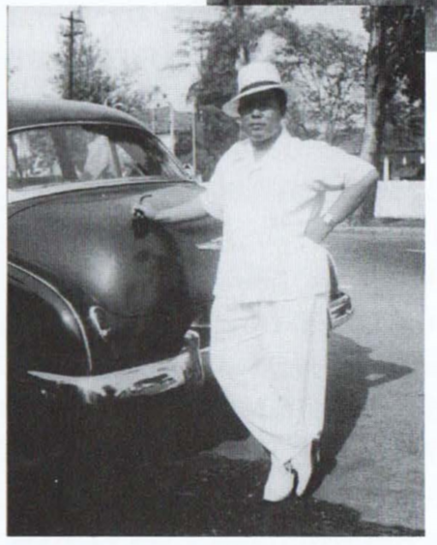
Resourches: H. Misbach Yusa Biran, Peran Pemuda dalam Kebangkitan Film Indonesia

At first, the studio is located in Kebayoran Persari built with bamboo and with thatched leaves. The founder of Persari, Djamaluddin did not have many theories about film business. He only has the determination to make films that are entertaining and marketable. The involvement of the theater group in Persari influenced the style and quality of the films produced. Almost all the films produced by Persari have the same style and quality as the plays and almost resemble Chinese films.[5]
Figure 2 : Persari's first studio in Kebayoran
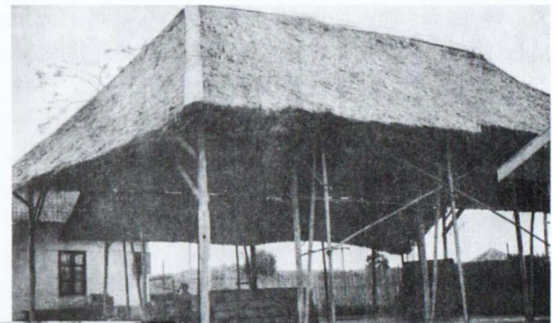
Resourches: H. Misbach Yusa Biran, Peran Pemuda dalam Kebangkitan Film Indonesia

The development of Persari was very rapid, in 1950 four films had been produced by Persari. Several film titles were produced in 1950, including Sedap Malam, Marunda, Pangeran Diponegoro, and Gambang Semarang..[6] In addition to film, in August 1950 at the Des Indes hotel in Jakarta, Persari also held a fashion show featuring western and eastern styles of clothing.[7] The rapid development of Persari is evidenced by the formation of Persari Film Distributors at the end of 1950, which served to circulate production films from Persari studios in cinemas throughout Indonesia. The name of Persaris's distributor business is Persari Film Distributors located on Jalan Hayam Wuruk 18 (East Molenvliet) Jakarta.[8]
Persari expands the film network to the Philippines. In early February 1950, Fernando Poe, a representative of the film company The Royal Film Company Of Philippines, came to Indonesia to discuss cooperation with Persari.[9] The collaboration is in the making of films and exchanges of artists from each company. The realization of the collaboration was carried out by exchanging artists. Artists from Persari that will be offered to Filipino film companies include Rd. Mochtar, Komala Sari, Netty Herawati and other artists from Persari.[10]

Figure 3 : Sedap Malam Movie Ads in theaters
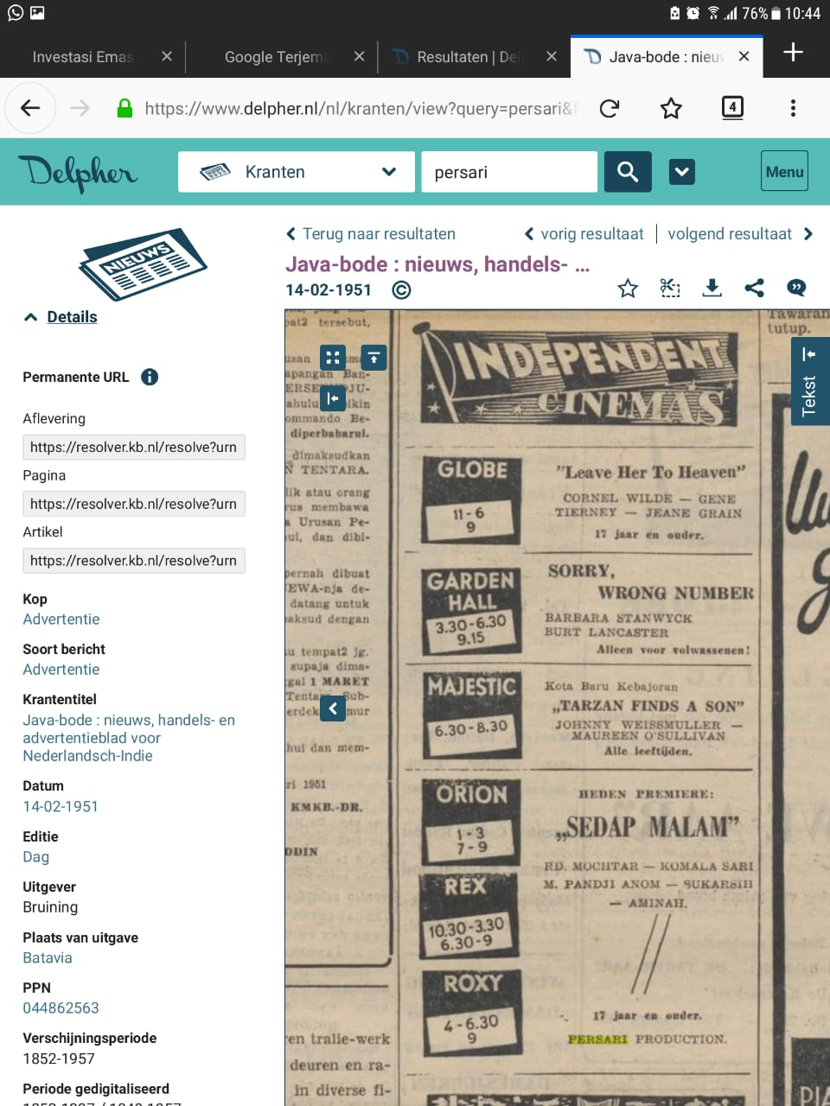
Sumber: Java-bode, Java-bode : nieuws, handels- en advertentieblad voor Nederlandsch-Indie, 22 Juli 1953, diakses melalui https://www.delpher.nl.

Persari is so productive in producing films. In 1952, Persari produced 12 films. Djamaluddin Malik as the leader of Persari aims to make films that are of interest to the public. From 1950 to 1954 37 films were produced, namely two color films made in the Philippines and three films made in Singapore.[11] Persari's success in producing films can be seen from its new office in Polonia Park, Jatinegara with an area of 33,000 m².[12] The beginning of the construction of this new studio was estimated in January 1951, because in the Java-Bode newspaper January 13, 1951, announced that Polonia Park since January 14, 1951 was no longer open to the public, because it was used for the studio Persari.[13]

Figure 4 : Sketch Studio Persari in Polonia, Jatinegara
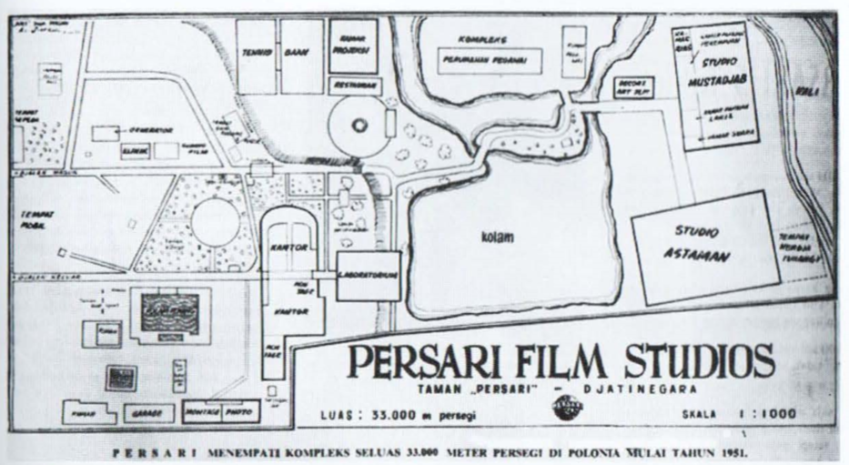
Resourches: H. Misbach Yusa Biran, Peran Pemuda dalam Kebangkitan Film Indonesia

- Invaliden
The impact of the war on Military Aggression I and II on Indonesia was that many physical buildings were destroyed, the economy was unstable, many people died and leaving painful memories of losing one or more limbs. Damaged physical buildings can be gradually reconstructed; An unstable economy can be fixed by making government regulations, but physical defects in the body of the army, will imprint a lifetime. This physical disability resulted in limited activities that made them unable to carry out military duties anymore. Therefore, the government also does not allow them to join the army.[14]
The fate of the invalent is in line with the Reorganization and Rationalization (Re-Ra) program in the army. The reduction in the number of members of the army was carried out by the government because the government economy was not yet stable due to the war. Therefore, Re-Ra was carried out for the effectiveness and efficiency of state expenditure, specifically for the needs of paying soldiers. In Java, the Re-Ra led to the reduction of many members of the army. The number of troops in Java before rationalization was 350,000 regular members and 470,000 members of the people's army. The number of members of the army in Java dropped dramatically to 160,000.[15]
Re-Ra's policy was carried out by Hatta in three ways, namely releasing troops who wanted to leave the army, surrendering the army to be fostered by the Ministry of Development and Youth, and returning the paramilitary army (laskar rakyat) to the community in their respective villages.[16] This rationalization of the army became an opportunity for the government to deactivate the invaliden forces. As stated in the Government Regulation of the Republic of Indonesia, Number 3 of 1950, states that to become a soldier II (the lowest rank) must follow the training of soldiers for six months; must have a diploma of at least a three-year People's School or equivalent education; a letter of good behavior from the civil service projo; A health certificate from a doctor; and 17 years old.[17]
These conditions are able to abort the desires of troops who want to enter the TNI. The health of the troops is also a requirement to remain in the TNI. As in PP No. 3 of 1950 article 21, that the army will be honorably discharged from membership because it is time for retirement and health is disrupted until it can no longer carry out its duties as a member.[18] Invaliden who experience physical or mental disabilities as a result of the war are also mostly felt to be unable to carry out their duties as members, so they will be deactivated from TNI membership. They did not get any more salary as when they served as soldiers, this had an impact on the welfare of invaliden.
Invaliden in Indonesia are divided into two, namely the first is the invaliden of the TNI and the second, invaliden of laskar rakyat. Invaliden from the TNI will receive benefits from the government as stipulated in PP No. 6 in 1950. Allowances for members of the TNI who are no longer serving are given for 2/5 of the length of the year of service in the army and civil service with the provision given at least for one year and a maximum of five years. The amount is that for the first six months, 80 percent of the basic salary is given; then the next 12 months 60 percent of basic salary, and subsequent months 40 percent of basic salary.[19] Invaliden also received an additional allowance in addition to the allowance provided that the soldier who lost one limb or one eye would be given an additional Rp. 25 a month, and soldiers who lost two limbs or both eyes were added to an allowance of Rp. 50 a month.[20]
The allowances are given to soldiers disabled invaliden of TNI, while invaliden troops from civilian or laskar rakyat non-active people, can not be included in the TNI, but dekembalikan to their respective villages. The benefits received by the invalent from the TNI and the people's mass are different, this is in line with the statement of E.Z. Hadijd, the general chairperson of the Indonesian Disability Association, criticized the government for distinguishing between the invalids of the TNI and lascar rakyat.[21] Hadijd also stated that in Indonesia there were around 10,000 invalids.[22] Nasution said that laskar rakyat who returned to the village community were given a salary of six times a month's salary with a limit of Rp. 300 to Rp.600 given at one time.[23]
Organizations to accommodate invaliden were formed in each region in Indonesia. The purpose of these organizations is to help the welfare of Indonesian invaliden in each region. On June 18, 1948 the Djokjakarta Corps Invaliden was formed to assist invaliden in Yogyakarta. In addition to forming an organization, the Tri Bakti dormitory was also built as a residence for invaliden and its family, which was inaugurated in August 1949.[24] In addition to Yogyakarta, on January 17, 1950, the Indonesian Invaliden Association (Persatuan Invaliden Indonesia(PII)) Jawa Barat was formed with its center in Jakarta.[25] Before these two organizations, there were already invaliden organizations in other areas such as, in Malang, the Indonesian Invaliden Association (Ikatan Invaliden Indonesia (III)) was formed before the outbreak of Military Aggression I; in Solo, Blitar, Surabaya, and Kediri also formed an invaliden union.[26]

Figure 5 : President Soekarno visited the invalid residence
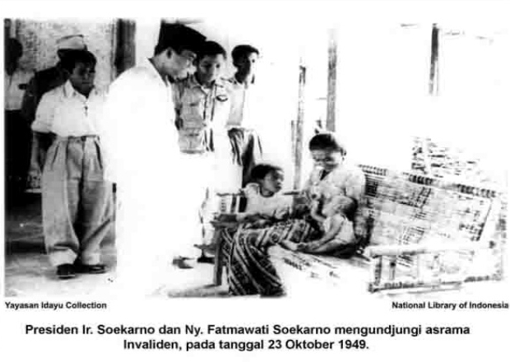
Sourches: ANRI IPPHOS No.1392

The formation of invaliden organizations is a concern for the plight of defective troops. The government and civil society carry out various activities to help their families. In line with the formation of the Indonesian Invaliden Association (PII) of West Java in 1950, the Indonesian War Victims' Foundation was also established with the aim of assisting invaliden. This organization has also helped members of the Jakarta Corps Invaliden (CID) in the form of course and school fees and material assistance for medical needs, death care, purchase of feed, boarding repairs and entertainment costs.[27] In addition to the foundation, there are also many private organizations and individuals that help invaliden, for example Persari (Indonesian Artist Company).
The number of enthusiastic to help invaliden and their families, then on May 18, 1950 formed the Indonesian Association of Invaliden (IISI) which accommodates organizations or corps of invaliden that exist throughout Indonesia. Then the name IISI was changed to the Association of Indonesian Disabled Patients according to the decision of the first congress in Bandung on August 18-23, 1951.[28]

- Pasar Malam Amal
Government and community efforts in helping both material and moral invaliden are still needed. Fundraising is done through charity activities, one of which is the pasar malam amal. Fundraising activities through the charity funfair are taken because they are considered effective for attracting people to come. People need entertainment, by coming to pasar malam and paying for admission, they have indirectly helped invaliden.
The market is a meeting place for sellers and buyers to transact. Usually, the market is held in the morning and sells a variety of basic needs, especially vegetables. Meanwhile there are also markets that conduct transactions at night, one of which is pasar malam. Transactions that occur at pasar malam are tourism transactions, usually selling culinary, handicraft items and providing children's playgrounds.
At present, pasar malam is a place of public entertainment for the lower middle class. Most people in this modern era have enjoyed the playground (playground) for their children in malls in the city, pasar malam still has enthusiasts as a place of entertainment that is not too draining the bag. At pasar malam presents games that can be enjoyed ranging from children to adults, so the funfair can be an alternative family tourist spot. Most night markets do not have to buy tickets at the moment, but every time they ride a game or enjoy a meal, new people pay what they use. The price offered for goods or culinary sold, is relatively cheaper when compared to the mall. For each vehicle ride, currently around Rp. 5000 to Rp. 20,000, as well as for culinary and hospitality items are also sold cheaply, with the lowest price of Rp. 1,000
Pasar malam, although currently the majority of people are interested in the middle to lower class, has an interesting history to be examined. In the beginning, pasar malam was an alternative place of entertainment for the entire city community, regardless of social strata. In Jakarta, precisely at Koningsplein (now Lapagan Merdeka or the people of Jakarta also call Gambir Field), in August-September 1906 the first pasar malam was held in Batavia which was intended to commemorate the ascension of Queen Wilhelmina on August 31, 1898. This pasar malam then became the agenda annual in the same month which is held for approximately two weeks. Previously, in 1863, Gambir was also used for public markets, more precisely the animal market (veemarkt), which not only sold animals but also held various competitions.[29] In these activities many people interest to com.[30] It turns out that several sources have noted that the crowd that provides a variety of spectacle is an alternative entertainment that becomes a magnet for the community. The attraction of the Gambir pasar malam was also recorded in the Bataviaasch nieuwsblad newspaper, on September 23, 1921, carrying 334,985 visitors, which means that in one second there was one visitor during the opening hours of the Gambir pasar malam. In fact, the Gambir Nigh.[31] Market Committee or committee stated that the activity gained a net profit of f 18,848.3,5.[32]
Pasar malam is in high demand, therefore many people use pasar malam to raise funds for charitable activities. The profits from pasar malam amal are used for charity or giving assistance to those in need, for example PII. Like pasar malam in general, pasar malam amal offers a lot of entertainment, such as playing arenas, product stands, culinary delights, as well as regional arts.
In January 1949 the Athletiek pasar malam amal was held at Koningsplein. In addition to presenting the arena of the game, also held an athletic race which will be held on Sundays and Mondays. On Sunday the 100m race was held at 03:45 and at 16:10 the javelin throwing match and at 16.20 there was the 100m run final.[33] Furthermore, on June 15 to July 15 there is also a pasar malam amal organized by the Indonesian Artist Company (Persari). The profit from pasar malam amal organized by Persari will be given to the Indonesian Invaliden Association of West Java.

Figure 6 : The opening of the Charity Market was attended by Ms. Kosasih, wife of the social minister
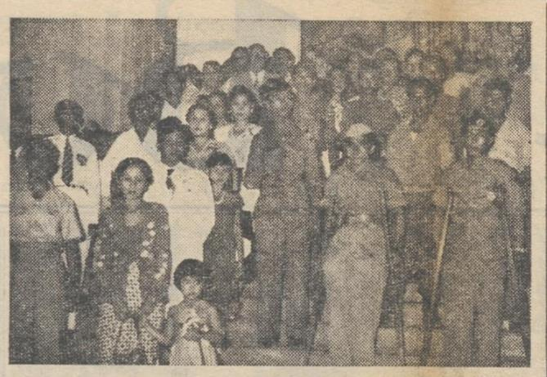
Sourches: Sumber: https://www.delpher.nl, “ Bij de plechtige opening van de Pasar Malam Amal” Java-bode : nieuws, handels- en advertentieblad voor Nederlandsch-Indie, 16-06-1950
Pasar malam amal, which is held by Persari, is located in Prinsen Park, Jakarta. The opening ceremony of pasar malam was attended by the wife of the Minister of Social Affairs. At pasar malam, Persari offers a variety of entertainment, including Pancawarna skits, Sunda Sekar Wangi skits, Miss. Ribut Revue, circus, Tiong Hwa in Hwa, Sundanese pencak, wayang people Krisdo Waluyo, Draai- and Radmolen, sunglap, public cinema from the Ministry of Information, tentoonstelingen from the Ministry of Social Affairs, Hula Dance, dancing bars and various other attractions.[34] On June 20, 1950, in order to welcom arrival of the Prime Minister of India, Pandit Nehru, Pasar malam amal will perform a Balinese dance whose dancers were imported directly from the island of Bali.[35]
Persari ran advertisements in newspapers to attract many people to their pasar malam amal. Pasar malam revenue is obtained from entrance tickets, booth rentals and advertising costs on advertisement books that will be distributed to visitors when they come to pasar malam.[36] Persari holds pasar malam amal because it wants to help invaliden. We can also see the social goals from the background of the founding of Persari who think of the old age of indigenous artists.

- CONCLUSIONS
Invaliden are people who are victims of the Indonesian War of Independence. Those whose fate seemed neglected by the government encouraged the community, both groups and individuals, to help them. Persari, one of the companies that had a social mission during its founding in 1950, also took part in paying attention to the fate of the nation's fighters. Fundraising is held through a charity funfair event. The funfair was chosen as the media to raise funds, because in the post-war era, funfair was the center of entertainment awaited by the community. That place can become a magnet to attract people. From the purchase of tickets and advertising, funds by Persari will then be handed over to the Indonesian Invaliden Association of West Java. Why was West Java selected, because the Persari headquarters was in Jakarta when RIS was included in the West Java Region.

REFERENCES
[1]  [2]  [3]  [4]  [5]  [6]  [7]  [8]  [9]  [10]  [11]  [12[  [13]  [14]  [15]  [16]  [17]  [18]  [19]  [20]  [21]  [22]  [23]  [24]  [25]  [26]  [27]  [28]  [29]  [30]  [31]  [32]  [33]  [34]  [35]  [36] | P. Jones, Liz Bradbury, Shaun Le Boutillier, Pengantar Teori-teori sosial. Dari Teori Fungsionalisme hingga Post-modernisme, (Jakarta: Pustaka Obor Indonesia, 2016), page 340.  Syarifuddin Jurdi, Sosiologi Nusantara: Memahami Sosiologi Integralistik, (Jakarta: Kencana, 2013) page 6.  Kuntowijoyo, Pengantar Ilmu Sejarah, (Yogyakarta: Bandung, 1995), page. 99.  H. Misbach Yusa Biran, Peran Pemuda dalam Kebangkitan Film Indonesia, (Jakarta: Kementerian Negara Pemuda dan Olahraga, 2009), page 76.  Neneng Ridayanti, “Peranan Perfini Dalam Mengembangkan Perfilman Nasional Indonesia, 1950-1970”, Jurnal Sejarah Citra Lekha , Vol. 2 , No. 1, 2017, hlm. 19-30.  “Advertentie Pemberitahuan”, Java-bode: nieuws, handels en advertentieblad voor Nederlansch-Indie, 18 Desember 1950.  “onder auspelen van de Persari”, Nieuwe Courant, 14 Agustus 1950. Diakses melalui https://www.delpher.nl  ”Pemberitahuan Bahwa Persari Film Distributors”, Java-bode : nieuws, handels- en advertentieblad voor Nederlandsch-Indie, 18 Desember 1950, diakses melalui https://www.delpher.nl.  “Philippijns Initiatief”, De nieuwsgier, 29 Januari 1951, diakses melalui https://www.delpher.nl.  “Uitwisseling van filmsterren”, Java-bode : nieuws, handels- en advertentieblad voor Nederlandsch-Indie, 08 November 1951. diakses melalui https://www.delpher.nl.  Neneng Ridayanti, op.cit.  H. Misbach Yusa Biran, op.cit., hlm. 78.  “Pemberitahuan”, Java-bode : nieuws, handels- en advertentieblad voor Nederlandsch-Indie, 13 Januari 1951. diakses melalui https://www.delpher.nl.  Kementerian Penerangan, Republik Indonesia Kotapradja Djakarta Raya, (Jakarta: Kementerian Penerangan), page. 392.  Y.A. Mohaimin, Perjuangan Militer dalam Politik di Indonesia 1945-1966, (Yogyakarta: Gadjahmada University Press. 1982)., page. 52.  Moh. Hatta. Mendajung antara Dua Karang. (Jakarta:Kementerian Penerangan Republik Indonesia. 1953)., pege. 15.  Peraturan Pemerintah Republik Indonesia, Nomor 3 tahun 1950, tentang Pengangkatan Penaikan Pangkat, Pemberhentian, Pernyataan Non-Aktif dan Sebagai Anggota Angkatan Darat R.I.S., pasal 7 dan pasal 14.  Ibid.  Peraturan Pemerintah Republik Indonesia, Nomor 6 tahun 1950, tentang Peraturan Sementara tentang Pemberian Tunjangan-tunjangan kepada Anggota TNI yang ada padaPenyerahan Kedaulatan Tidak masuk Angkatan Perang Republik Indonesia Serikat. Pasal 2. Ini juga tertuang dalam Undang-undang nomor 19 tahun 1950 tentang peraturan Pensiun dan Onderstan kepada Para Anggota Tentara Angkatan Darat. Pasal 7.  Ibid., pasal 3, ayat 1 a dan b.  “Invaliden Vragen Meer Belangstellingen”, Java-bode : nieuws, handels- en advertentieblad voor Nederlandsch-Indie, 22 Juli 1953, diakses melalui https://www.delpher.nl.  Ibid.  A.H. Nasution, Sekitar Perang Kemerdekaan Indonesia jilid 7 (Periode Renville), (Bandung: Disjarah A.D. dan Angkasa, 1978), page. 132.  “De republikense invaliden”, De vrije pers: ochtendbulletin, 23 Agustus 1949, diakses melalui https://www.delpher.nl.  Kementerian Penerangan, Republik Indonesia Kotapradja Djakarta Raya, Jakarta: Kementerian Penerangan, (TT)., hlm. 392.  https://museummiliterku.blogspot.com/2017/06/kenang-kenangan-invaliden-sersan-paidjo.html, diakses pada 29 Juni 2020 pukul 21.45 WIB.  Kementerian Penerangan, Op.cit., hlm. 393.  “Geen onderscheid tussen Voormallige guerila’s,” Algemeen Indisch dagblad : de Preangerbode, 24 Agustus 1951, diakses melalui https://www.delpher.nl  "Veemarkt". Java-bode : nieuws, handels en advertentieblad voor Nederlandsch-Indie. 1863-04-29. diakses melalui https://www.delpher.nl  Ibid.  De Passar Gambir, Bataviaasch nieuwsblad, , 23-09-1921. diakses melalui https://www.delpher.nl  ibid  “Pasar Malam Amal Athletiek”, Het dagblad uitgave van de Nederlandsche Dagbladpers te Batavia, 28 Januari1949.  “Pertundjukan Istimewa Pasar Malam Amal” Java-bode : nieuws, handels- en advertentieblad voor Nederlandsch-Indie, 20 Juni1950, diakses melalui: https://www.delpher.nl.  Ibid.  “Pasar Malam Amal untuk Persatuan Invaliden Indonesia Djawa Barat”, Java-bode : nieuws, handels- en advertentieblad voor Nederlandsch-Indie, 20 Juni1950, diakses melalui: https://www.delpher.nl.

