**The Influence of Employee Demotivation and Employee Motivation on Employee Performance: A Study of Veesit Technology**

Lia Mayasari

Bachelor of Entrepreneurship, School of Business and Management

Institut Teknologi Bandung, Indonesia

lia_mayasari@sbm-itb.ac.id

**ABSTRACT**

Employee demotivation is a common thing experienced by many startup employees that apparently affects negatively to the employee performance, including Veesit Technology, a growing stage startup that is running by college students. In this research, the author is focused on college student startup to determine the highest demotivation factor and the highest motivation factor that affects to employee performance. The dependent variables used are The main purpose of this research is to determine the influence of employee motivation and employee demotivation on employee performance. The researcher gathers the data from 93 college students who work at a startup through online questionnaires and analyzes data to determine a range of statistical and concise findings. To evaluate the data, the author will use Multiple Linear Regression. After all, this has been developed, in particular in the startup of college students, the goal is to find the greatest factor that can potencially increase employee efficiency and improve the startup.

**Keywords**: Employee Demotivation, Employee Motivation, Demotivation Factors, Motivational Factors, Employee Performance

**1. INTRODUCTION**

The growth of the IoT has been phenomenal in terms of sales volume and the number of enterprise and individual adopters. (Lee, 2019)In the face of global and digital competition, every individual or group within a company or organization is required to have good abilities, so they can compete and excel in the competition that will be increasingly difficult. (Ruutu, et al., 2016)

In Indonesia, the number of young people who want to enter business has gradually begun to increase, along with its development even though the number of entrepreneurs remains far behind from the developed countries of the United States and Japan, which have more than 14%. Almost 62 percent of respondents want to become technology entrepreneurs and 2-5 percent of fresh graduates who join the business sector. (Fauziah, 2019)

Veesit technology, as one of the example, is a growing stage startup. However, this startup is facing a cruicial problem that affects their job description accomplishment, their company monthly target, and probably could threaten their sustainability. The main problem of the company is they were experiencing demotivation while working at their startup. This can be proven by evaluating their performance in the Key Performance Indicator (KPI) target. On average monthly, KPI progress only reaches at level 10% where maintaining high productivity especially in early stage business is important. Meanwhile, according to (Jarour, 2014) the motivation aspect takes a big role that creates the drive to work at the best of their abilities. As this problem is also faced by common startup companies, this research may be useful for any college student startups.

On the other hand, motivation theory is understood so that leaders can understand the reasons that drive people to work and maintain the working relationship with motivation. Motivation is necessary because people have basic needs to be fulfilled. According to Abraham Maslow that humans have five levels or hierarchies of needs, namely physiological needs as the most basic requirement such as clothing, food, and shelter, the need for a sense of security, the need for ownership, the need to love and be loved, the need for self-esteem, and the need for self-actualization which is the sense of the availability of one's opportunity to develop the potential contained in him so that it turns into real abilities. If a person's basic needs are not met, then it will be difficult to maintain his life let alone achieve satisfaction and reach a higher level of need, namely the highest is self-actualization. Inability to meet human needs and the feeling of not receiving enough motivation or support from a certain thing can cause a person to experience demotivation. (Dr.H. Adie E. Yusuf, 2008)

When a person is experiencing demotivation, he will experience the demotivation journey and along with the length of work can decrease employee work performance. The causes of demotivation differ from one person to another. Sometimes, secondary initiatives cause demotivation for people such as the daily routine of work. Management of any organization must conduct periodic studies of their employees to witness some changes to rid employees of the causes of demotivation. (Jarour, 2014)

1. **HYPOTHESIS DEVELOPMENT**

Employee Demotivation

(X1, X2, X3)

H2

Employee Performance

H1

Employee Motivation

(X4, X5, X6, X7, X8)

**FIGURE 3. 1 Research Framework**

The research framework is based on (Arabi, et al., 2013) to determine the highest demotivation factor and the highest motivation factor that affects employee performance. This research is willing to find the greatest factor that may potentially increase employee efficiency and the startup.In this research, the author has employee demotivation and employee motivation as the independent variables. In demotivation factors, the author has three independent variables (X1, X2, X3) and in motivational factors, the author has five independent variables (X4, X5, X6, X7, X8). The list of variables orderly from X1 to X8 are: “Incompetent Team”, “Organization Workload”, “Organization Culture”, “Recognition from Team”, “Teamwork and Strong Spirit”, “Chance to Develop Performance”, “Evaluation and Feedback”, and “Performance based Reward and Punishment”. We use employee performance as dependent variable (Y1).

Thus, a number of hypotheses were developed based on the context to assess the validity of the frame assumption.

H1: The *highest* demotivational factor may affects employee performance.

H2: The *highest* motivational factor may affects employee performance.

1. **RESEARCH DESIGN**

Research design is a part of the research process that describes and defines research methodology from the problem to its conclusion.

**FIGURE 3. 2 Research Design**

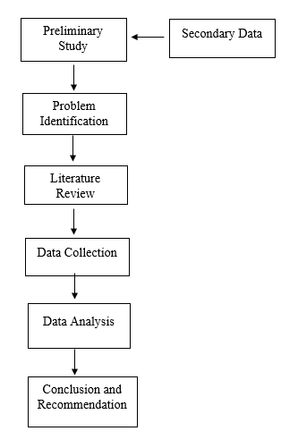

Problem statement of this research is to understand the highest demotivation factor and the highest motivation factore that causes employee performance by identifying existing factors. The steps or process to answer the questions in this study are shown in the picture above.

1. **RESEARCH ANALYSIS**

### 4.1 Multiple Regression Analysis

#### 4.1.1 F-Significance Test

Upon checking with classic assumptions, the f-sig test is designed to demonstrate that this sample is representative of the target population using an ANOVA table. If the significant value is below 0.05, it means that the independent variable (X) simultaneously influences the dependent variable (Y).

**TABLE 4. 1 F-Significance Result**

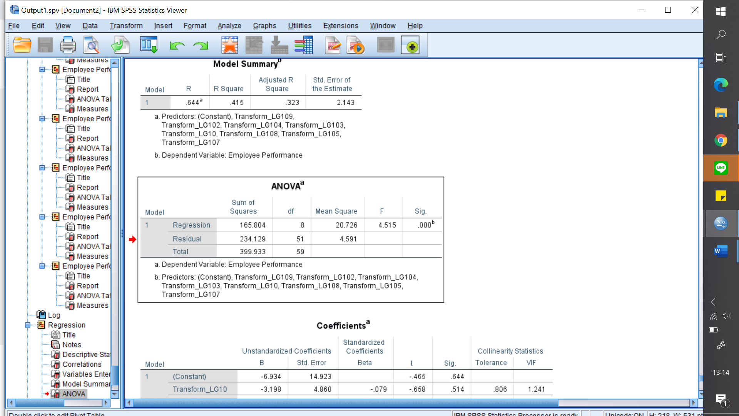

From the F data on the table above, we can see that the significance is 0.044 (below 0.05), so the model is considered good and representative.

#### 4.1.2 R-Square test

R-squared is a statistical measure of data's closeness to the fitted regression line. This method is important to test human’s behavior and psychology. From the table below, we can see that the R result is and the dependent variable of R results is 0.644 and can explain 41.5% the variability of data collected. The other 58.5% is explained by other factors.

**TABLE 5. 2 R-Square Result** 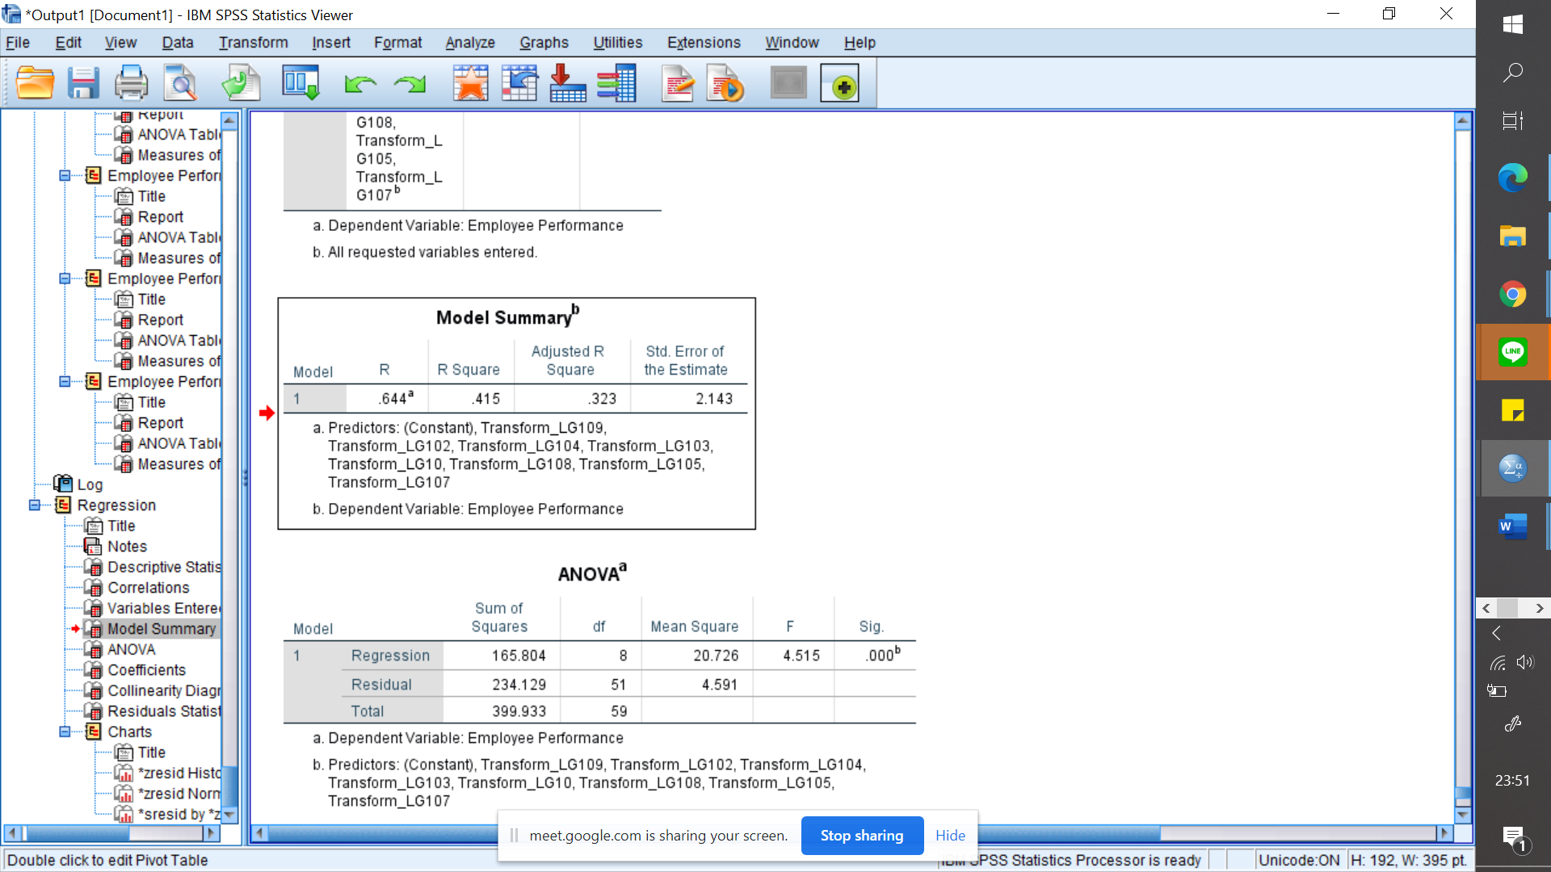

#### *4.1.3 Regression Coefficients (T-Test)*

The T-test is to compare the most significant independent variables to the dependent variable. To answer knowing the highest factor, we can see the "t-test". With a total of 69 respondents, the t-table score was 1,667.

**TABLE 5. 3 T-Significance Result** 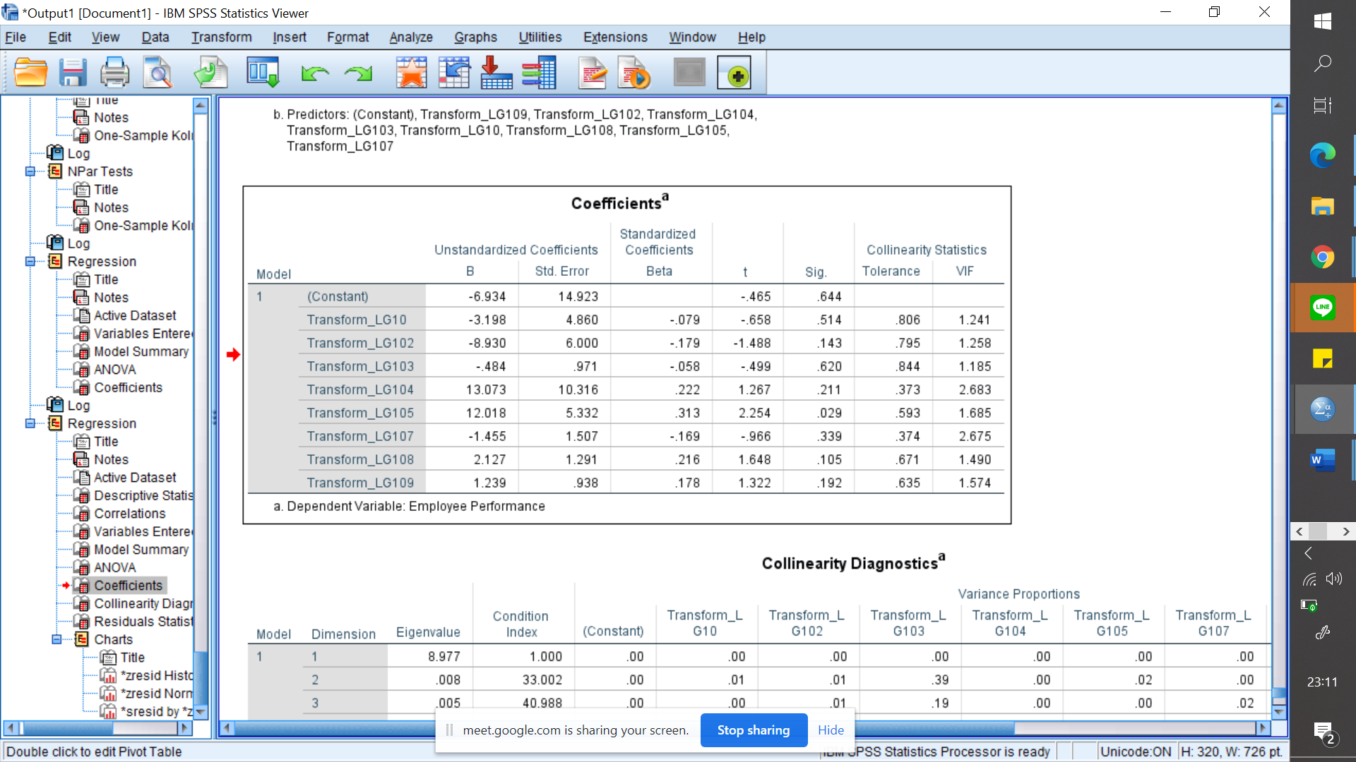

Based on t-tables and calculated-t we can see that the highest number for employee demotivation is Transform_LG108 (OW) with the number of 0.216 and the highest number for employee motivation is Transform_LG108 (RT) with the number of 2.254.

1. **CONCLUSIONS**

**5.1 Highest Factor of Demotivation**

According to (Osman, et al., 2016), many startups failed in their very early stages, facing struggle, and fewer than one percent transform into companies. In running the startup, there are a lot of challenges that commonly called “startup problems”. Regarding to the problems, the author has conducted a research with 69 respondents through online questionnaire and analyzed it with Multiple Linear Regression. This research is aimed to answer the influence of employee demotivation and employee motivation on employee performance. In this study, the author will answer the highest factor of demotivation and motivation factor that affects employee performance. Based on this study, it is known that demotivation has an influence on employee performance. It is known that Organization Workload holds the highest factor in causing employee demotivation. The result is equal to 0.216 (above the number of significancy 0.05), which means it has enough influence negatively to employee performance.

**5.2 Highest Factor of Motivation**

From the results of the study, it was found that Recognition from Team was the highest variable in its effect on employee performance. This recognition from team got a score of 2,254 in calculated values and was greater than the t-table. This means recognition from the team has a large and very significant influence in motivating employees and can have a positive influence on employee performance.Similar with (Arabi, et al., 2013) saying that another factor affecting people at work is a friendly environment, as this factor has been established have a strong effect on employee success at service organisations. A large number of workers are likely to leave their jobs while under pressure. Friendly environment at work, workers may be motivated by committing themselves to the successful execution of their assignments and duties. Similarly, cooperation between employees and management would lead to the development of a healthy working climate. (Arabi, et al., 2013)

The author’s recommendation for further research is to conduct the research on a larger population and sample size is required to improve the generalizability of conclusions. The findings of this study suggest that there is a need to recognize certain variables which may be of interest to employees as such factors are likely to affect their performance. Moreover, it should have included more demotivation, motivation, and other factors that could have influenced on job performance in order to obtain more comprehensive understanding of factors that influence on job performance.

# REFERENCES

1. Aghayeva, K. & Slusarczyk, B., 2019. Analytic Hierarchy of Motivating and Demotivating Factors Affecting Labor Productivity. *Sustainability,* p. 14.
2. Arabi, M. S., Akeel, A. B. A. A. B. & Subramaniam, I. D., 2013. Relationship between Motivational Factors and Job Performance of Employees in Malaysian Service Industry. *Asian Social Science,* Zväzok 9.
3. Dr.H. Adie E. Yusuf, S., 2008. *Teknologi Kinerja.* [Online]   
   Available at: https://teknologikinerja.wordpress.com/2008/05/06/pengaruh-motivasi-terhadap-peningkatan-kinerja/  
   [Cit. 8 May 2008].
4. Fauziah, S., 2019. *www.brilio.net.* [Online]   
   Available at: https://www.brilio.net/serius/kesempatan-mahasiswa-rintis-bisnis-startup-teknologi-kian-besar-190219t.html#  
   [Cit. 20 February 2019].
5. Jarour, S. F. A.-., 2014. Person Demotivation in Organizational Life. *International Journal of Business and Social Science ,* 5(1), p. 219.
6. Lee, I., 2019. The Internet of Things for enterprises: An ecosystem,. *Internet of Things,* Zväzok 7, pp. 1-13.
7. Osman, S., Shariff, S. H. & Lajin, M. N. A., 2016. Does Innovation Contribute to Employee Performance?. *Procedia Social and Behavioral Science,* Zväzok 219, pp. 571-579.
8. Ruutu, S., Casey, T. & Kotovirta, V., 2016. Development and competition of digital service platforms: A system. *Technological Forecasting & Social Change,* -(-), pp. 1-12.
9. Salamzadeh, A. & Kesim, H. K., 2015. Startup Companies: Life Cycle and Challenges. *Research Gate.*